Air Masses and Fronts Name: _________________________________

Air Mass: large body of air where ________________ and ____________ are similar throughout
Moist: ______________
Forms over _____________ Label each air mass with its name below:
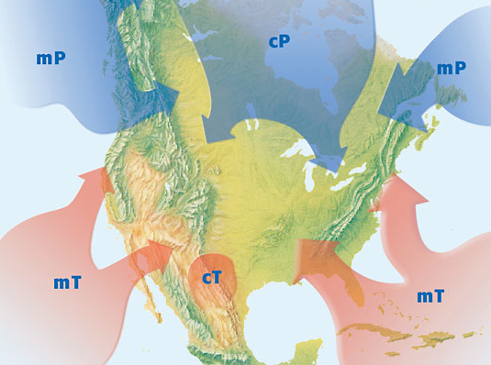
Dry: ________________
Forms over ____________
Warm: _______________
Forms over the ___________
Cold: _________________
Forms over the ______________

Describe the 4 types of air masses:
mT: ______________________
mP: _____________________
cT: ______________________
cP: _______________________

________________=where 2 air masses meet

4 TYPES OF FRONTS
______ Front _______ Front
>>cold air moves under warm >>warm air moves over colder
air and pushes up the warm air and denser air
>>thunderstorms >>drizzle and light rain
>>brings in ___________air >>warmer temperatures

Draw what it looks like below: Draw what it looks like below:

Occluded Front _______________ Front
>>warm air mass trapped between >>little or no movement
two colder air masses of the air masses
>>brings cooler temperatures >>many days of clouds and rain
and lots of _____________ >>sometimes floods

Draw what it looks like below: Draw what it looks like below:

Study Jams Quiz
- What is an air mass?
  - A place where weather always changes in an extreme way
  - A large body of air with the same temperature and moisture
  - Any kind of cloud that produces rain, sleet, snow or hail
  - Any kind of air, as long as it is always wet and freezing
- What forms when two air masses meet and create weather?
  - A formation
  - Warm air
  - A front
  - A tornado
- When a cold air mass crashed into a warm air mass, what kind of front is formed?
  - Cold front
  - Warm front
  - Hot front
  - Polar front
- Why does a warm front usually bring a light and steady rain?
  - Warm fronts bring extremely low air pressure
  - Weather that is not intense always happens at any kind of front
  - A warm air mass violently crashes against a cold air mass, so the weather is wet
  - A warm air mass slowly climbs up over the cold air mass, so the weather is less intense

- Which kind of front usually forms long, thin stratus clouds?
  - Polar front
  - Cold front
  - Warm front
  - Hot front
- What is similar between the two kinds of maritime air masses?
  - Amount of moisture in the air
  - Temperature of the air mass
  - Geographic location
  - Types of clouds they form
- What would most likely happen if a continental polar air mass clashed with a continental tropical air mass?
  - The clouds would disappear, and the day would become clear and sunny
  - Cumulus clouds would form, and a big thunderstorm would occur
  - Stratus clouds would form, and they would make the day warmer
  - Clouds would form, and they would bring light and steady rainfall.

Label the fronts that you see in the map below.
- What type of weather is associated with front #1? ________________________________________________

- What type of weather is associated with front #2? ________________________________________________

- What type of weather is associated with front #3? ________________________________________________

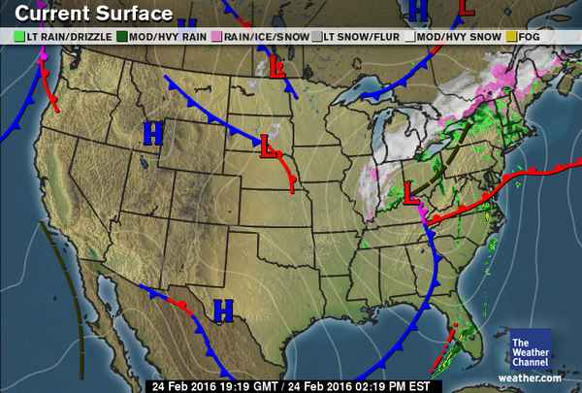
- What type of weather is associated with front #4? ________________________________________________
4.
3.
1.
2.

