Astronomy- Unit 8 – SOLAR SYSTEM NOTES
Our Solar System
Which object is the largest: Earth, the sun, the Milky Way Galaxy or a supergiant star? | Where in the Milky Way Galaxy is the solar system found? | A light year is a unit of ________________.

Includes the __________________, ___________ planets, their moons, ________________, comets, ___________________ and other smaller objects (like Dwarf Planets).
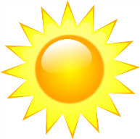
You’re a Sun! (A Star that is)

It is _______________ (color), _____________ (age), ________________ (size), ______________ (temperature), _________________ (brightness)
PLANETS
Inner planets
- Also called _________________ planets
- ____________, _____________ and rocky
- No _________________ (yes, they are single)
- Includes
-________________ (The Hot one)
- ________________ (Earth’s Twin)
-________________
- ________________ (Might be able to support life)
Outer Planets
- Also called __________________________
- All have _______________________.
- All have at least one __________________. (They’re married)
- Includes
- _______________________ (BIGGEST)
- _______________________ (Many rings)
- _______________________
- _______________________ (Ice giant)

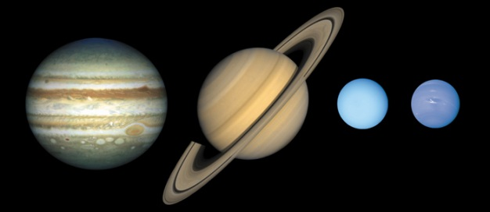
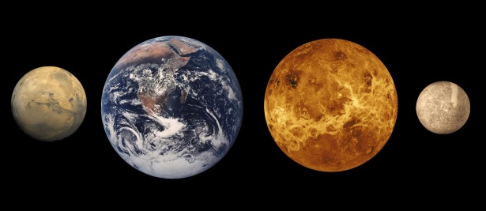

Review:

Order the planets in order from biggest to smallest:
Order the planets starting from the Sun:

