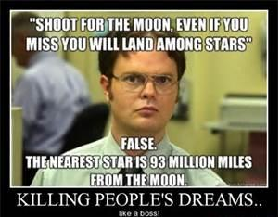
Astronomy- Unit 8 – The Moon

The Moon
- It’s called the ____________ of the Earth.
- Surface temperature can be __________ to ____________ degrees Celsius
- Surface Gravity: _______ % of Earth’s
- About _____________________ km away
(took Apollo about 3 days to get there)
FEATURES
- Craters – From ________________
- ___________ - dark, smooth areas
- HAS NO __________________ (so NO weather, no erosion)

PHASES OF THE MOON

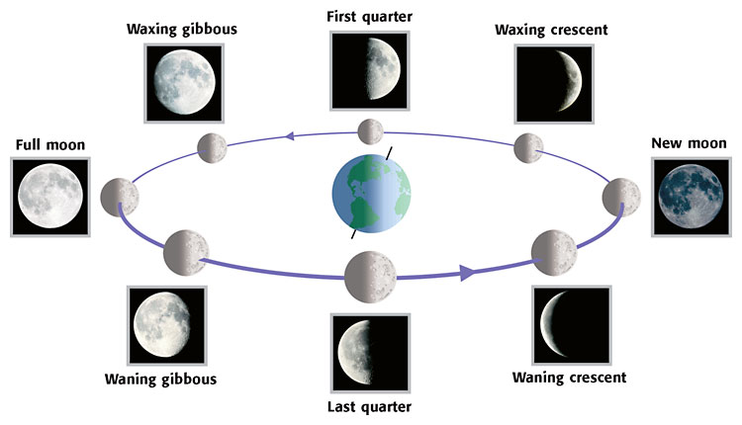
S
U
N

SOLAR ECLIPSE
The passing of the ________________________ between the Earth and Sun. The _________________ of the moon falls on the ____________________
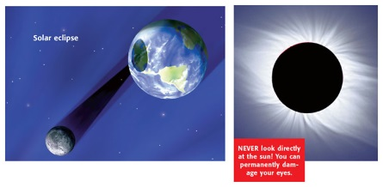

LUNAR ECLIPSE
The passing of the moon through the ___________________’s ___________________ at __________________ moon.
