Name: _____________________________________________ Date: _______________ Period: ___________
Unit 8: Astronomy STUDY GUIDE
Part 1 – Seasons
- What causes a planet to have seasons?

- How long is Earth’s rotation?

- How long is Earth’s revolution?

- What is the date and name of the first day of each season?

Part 2 – Early Models
- Heliocentric vs Geocentric Models of the universe/solar system.

- According to the big bang theory, how old is our universe?

- What does the Big Bang Theory state about our universe? Is the universe currently expanding or contracting?

Part 3 – Galaxies
- What is the name of our galaxy? What does it look like?

- Where are we located in our galaxy?

Part 4 – Planets
- List the planets in order, starting from the Sun? (remember the sun is a star, and moons are not planets)

- What two forces allow the planets to stay in their orbit?

- What do all inner planets have in common?

- What do all outer planets have in common?

- List the inner planets and give 3 distinguishing characteristics for each.

Part 5—Outer planet
- List the outer planets and give 3 distinguishing characteristics for each.

Part 6—Moon Phases: Make a double bubble for each (or list three differences and three similarities)
- waxing and waning

- crescent and gibbous

- full and new moon

- quarter moons (1st and third/last)

PHASES OF THE MOON

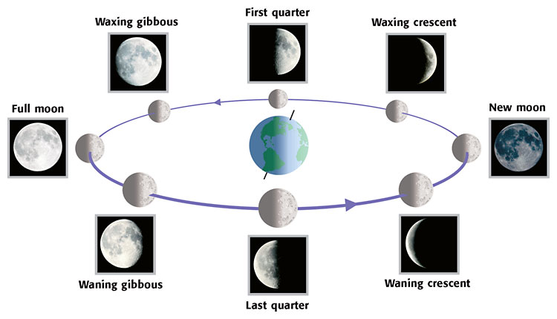
S
U
N

Part 7–Eclipses
- What type of eclipse is seen when a new moon moves in front of the sun (unsafe to look at directly)?

- What type of eclipse is seen when the Earth’s shadow moves in front of the full moon (safe to look at)?

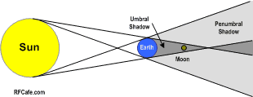
- Is this a solar or lunar eclipse? What phase of the moon would it be?

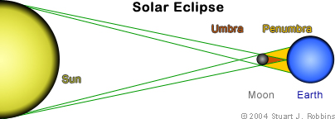
- Is this a solar or lunar eclipse? What phase of the moon would it be?

Part 8—Other objects in our solar system
- What does a comet look like, and how does it form?

- What creates craters?

- What does a meteor look like, and how does it form?

- What are asteroids, and where are most found?

- Meteoroid, meteor, meteorite (where are each found?)

