Name: _____________________________________________ Date: _______________ Period: ___________
Unit 8: Astronomy STUDY GUIDE ANSWERS
Part 1 – Seasons
- What causes a planet to have seasons? The earth’s tilt which causes indirect and direct sunlight

- How long is Earth’s rotation? 24 hours

- How long is Earth’s revolution? 365 days = 1 year

- What is the date and name of the first day of each season?
March 21st – Vernal Equinox (Spring)
June 21st – Summer Solstice (Summer)
September 21st – Autumnal Equinox (Fall)
December 21st – Winter Solstice (Winter)

Part 2 – Early Models
- Heliocentric vs Geocentric Models of the universe/solar system.
Heliocentric has the sun in the center, Geocentric has Earth in the center. Neither are completely correct.

- According to the big bang theory, how old is our universe?
14.5 BILLION years old

- What does the Big Bang Theory state about our universe? Is the universe currently expanding or contracting? It states that all time, mass, and energy were compressed into a small ball and suddenly exploded. YES, The universe is still expanding.

Part 3 – Galaxies
- What is the name of our galaxy? What does it look like?
Milky Way, Spiral

- Where are we located in our galaxy?
An outer band call the Orion Arm

Part 4 – Planets
- List the planets in order, starting from the Sun? (remember the sun is a star, and moons are not planets)
Mercury, Venus, Earth, Mars, Jupiter, Saturn, Uranus, Neptune

- What two forces allow the planets to stay in their orbit?
Gravity keeps us in orbit, Inertia keeps us moving

- What do all inner planets have in common?
They all have rocky surfaces, the all have 0-2 moons, none of them have rings

- What do all outer planets have in common?
They are all gas giants, they all have many moons, they all have rings

- List the inner planets and give 3 distinguishing characteristics for each.
Mercury: smallest planet, shortest year, closest to the Sun
Venus: Earth’s “twin”, hottest planet, atmosphere has sulfuric acid
Earth: we live here, has water, supports life
Mars: Red because of Iron, may support life, has two moons

Part 5—Outer planet
- List the outer planets and give 3 distinguishing characteristics for each.
Jupiter: biggest planet, Great Red Spot, gas giant
Saturn: has rings, can float in water, gas giant
Uranus: tilted on it’s side, gas giant, blue
Neptune: farthest planet from sun, longest year, gas giant

Part 6—Moon Phases: Make a double bubble for each (or list three differences and three similarities)
- waxing and waning
Waxing is getting bigger, right side is lit, moon is getting farther from sun
Waning is getting smaller, left side is lit, moon is getting closer to the sun
Both types of moon phases

- crescent and gibbous
Crescent is less than ½ of the moon lit, when the moon is close to the sun
Gibbous is more than ½ of the moon lit, when the moon is far from the sun
Both types of moon phases, both can be waxing or waning

- full and new moon
Full is when all the lit side is shown, farthest point from the sun, a lunar eclipse can only happen during this phase
New moon is when NONE of the lit side is shown, closest point from the sun, a solar eclipse can only happen during this phase
Both are moon phases

- quarter moons (1st and third/last)
1st quarter has right side lit, it is waxing, it is getting farther from the sun
3rd quarter has left side lit, it is waning, it is getting closer to the sun
Both are moon phases

PHASES OF THE MOON

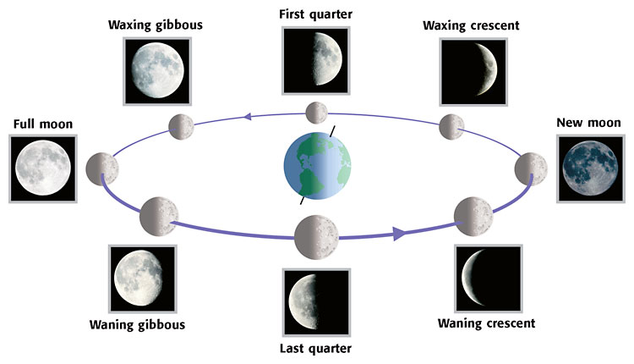
S
U
N

Part 7–Eclipses
- What type of eclipse is seen when a new moon moves in front of the sun (unsafe to look at directly)?
SOLAR ECLIPSE

- What type of eclipse is seen when the Earth’s shadow moves in front of the full moon (safe to look at)?
LUNAR ECLIPSE

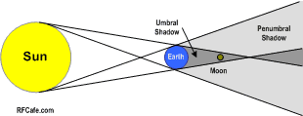
- Is this a solar or lunar eclipse? What phase of the moon would it be?
LUNAR ECLIPSE
FULL MOON

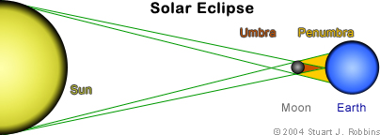
- Is this a solar or lunar eclipse? What phase of the moon would it be?
SOLAR ECLIPSE
NEW MOON

Part 8—Other objects in our solar system
- What does a comet look like, and how does it form?
A streak of light. Ice melting

- What creates craters?
Meteorites

- What does a meteor look like, and how does it form?
Shooting star, rock burning up in Earth’s atmosphere

- What are asteroids, and where are most found?
Large rocks in space. Asteroid belt

- Meteoroid, meteor, meteorite (where are each found?)

Meteoroid is in space
Meteor burns up in Earth’s atmosphere
Meteorite hits Earth’s surface

