Unit 3 Study Guide
Section 1: Atmosphere and air pressure

Atmosphere= mixture of ___________.
Purposes of our atmosphere:
- ______________________ (oxygen)
- Protects us from harmful ___________rays
(ultraviolet and gamma)
- ____________________ (traps heat)
- Water/water vapor
- Protects us from most ______________ from space
What gases makes up DRY air?
- Nitrogen- ____%: the most common atmospheric gas (used to make ____________)
- ______________________- 21% (made by photosynthesis of phytoplankton and plants)
  - Cellular respiration
  - _____________ (rust ; tarnish)
  - ______________________ (burning)
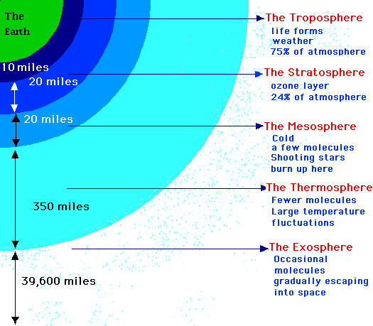
- Other gases-1%: argon, ________________,
and other gases

Air also contains:
- ___________________ (smog, etc)
- Natural ________________: dust, volcanic ______, sea salts, dirt, ______________, smoke from forest fire
- Water ______________ (gas) (humidity)—amount varies (0--____%)
- Liquid water (clouds and ___________)
- Solid water (ice and _____________)

Air Pressure—see visual organizer…
Give the circle graph below a title, then label the 3 sections

