Name: _________________________________________________________________ Date: ____________________________ Period: ________________
Asteroids, Meteors, Comets… oh my!
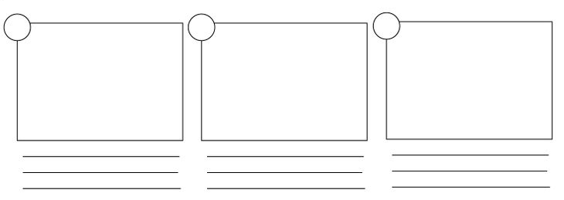
Create a comic/flow map about meteors, meteoroids, and meteorites below (This should explain the difference between the three)
Create a comic/flow map about comets below (This should explain where they come from and what they are made of)
Create a comic/flow map about asteroids below (This should explain where they are located and what they are made of)

