Continental Drift and Plate Tectonics Guide
Alfred ____________ noticed the continents seemed to fit together (1915). This large landmass was called___________________________ started splitting apart 180 _____________ years ago (dinosaurs were around).
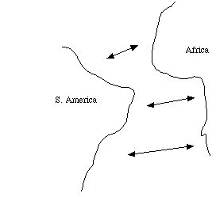
Evidence to support Pangaea includes:
1.
2.
3.
>Pangaea separated according to the theory of
Continental ______________.
>In your own words, describe how fossil evidence supports Continental Drift.

Evidence after Wegener’s death (1930)…
What is seafloor spreading?
On the diagram below, label the oldest and youngest ocean crust.
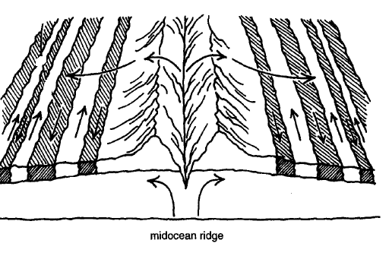
The ______________________________ is divided into ten tectonic ___________________.
(remember: lithosphere floats on asthenosphere)
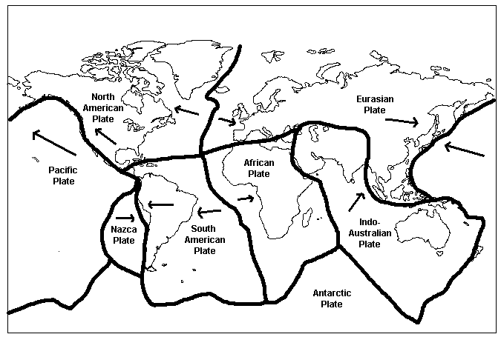
3 types of plate boundaries (see fill-in chart for details):
1.
2. divergent
3.

What causes tectonic motion?
______________________ in asthenosphere
>>Lithospheric plates move about ____ cm per year.

How Did the Continents Form?
By Patti Hutchison
You know that there are seven continents on earth today. But did you know that in the past, the earth looked very different? Sometimes there were more continents. Sometimes there were fewer continents. How did the continents form? The answer is plate tectonics. During the Proterozoic Eon there were hundreds of small pieces of crust floating on the mantle. These first land masses were small continents and island arcs. They collided with each other because of plate tectonics. The pieces of crust hit so hard, they jammed together. At the boundaries, much energy was released. The land fused together. By 2.5 billion years ago, about one-fourth of the earth's crust was formed. These ancient land masses were known as shields. They moved all the time. Larger bodies collided with smaller ones. Mountains were formed at the edges. Lava flowed and welded these pieces together. The first true continent appeared about three billion years ago. It was called Ur. It contained parts of what are now Africa, India, Australia, and Antarctica. Another continent called Artica surfaced about 2.5 billion years ago. It contained what is now North America and part of Asia. Half a billion years later, Atlantica and Baltica were formed. These contained parts of present-day South America, Africa, and Europe. Soon, Baltica and Artica collided. Mountains were formed on both continents. By this time, 80% of the earth's continental crust had been formed. These four continents floated around on the mantle for many years. About 1.5 billion years ago, Artica and Baltica bumped into what is now eastern Antarctica. This formed the continent of Nena.
A billion years ago, the continents of Nena, Atlantica, and Ur came together. The supercontinent of Rodinia was born. Three million years later, Rodinia broke up. It separated into three continents once more. Later they came back together to form a new continent. It was called Pangaea. Pangaea was the last supercontinent. It later broke up into the seven continents we know today.

- At different times during Earth’s history, there were sometimes less than seven continents
  - True
  - False
- What process formed the continents? ______________________________________________________
- Ancient land masses were known as:
  - Mountains
  - Plate tectonics
  - Shields
- The first true continent was called:
  - Ur
  - Pangaea
  - Artica
- What three continents made up the supercontinent of Rodinia? _____________________________
- What was the last supercontinent called?
  - Pangaea
  - Ur
  - Rodinia
- In your own words, describe how plate tectonics caused the continents to grow:
______________________________________________________________________________________________
______________________________________________________________________________________________
______________________________________________________________________________________________
______________________________________________________________________________________________

