Seasons in our Solar System
PLANET | AXIAL TILT  (Approximate) | ORBIT TIME  (One Year: Units of Earth  Years and Days) | PLANETARY SIZE  (Scaled to mm) | DISTANCE FROM THE SUN (AU)
Mercury | 0° | 88 days | 9 mm | 0.39 AU
Venus | 177° | 225 days | 21 mm | 0.72 AU
Earth | 23° | 365 days | 23 mm | 1 AU
Mars | 25° | 687 days | 12 mm | 1.52 AU
Jupiter | 3° | 12 years | 250 mm | 5.2 AU
Saturn | 27° | 29 years | 220 mm | 9.58 AU
Uranus | 98° | 84 years | 90 mm | 19.2 AU
Neptune | 30° | 164 years | 87 mm | 30.1 AU
Pluto | 120° | 248 years | 4 mm | 39.5 AU

Seasons are each of the four divisions of the year (spring, summer, autumn, and winter) marked by particular weather patterns and daylight hours. Study the chart above. Determine what information is valuable to compare Earth’s seasons with seasons of other planets. Answer the following questions:
--------------------------------------------------------------------------------------------------------------------------------------------------
1. Which column(s) are least helpful when determining if a planet will experience seasons?

2. Which planet(s) would not likely have distinct seasons? How do you know?

3. Assuming there were four distinct seasons, how many days would each season last on Mars?

4. How many days would each season last on Saturn and Neptune?
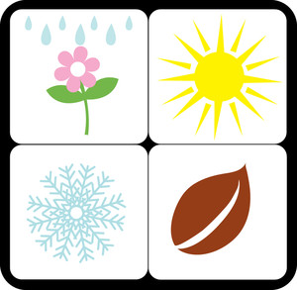
a. Saturn
b. Neptune

5. Pretending that we could actually exist on Saturn and that you would get a new coat each winter, how many new coats would you have gotten in your lifetime?

