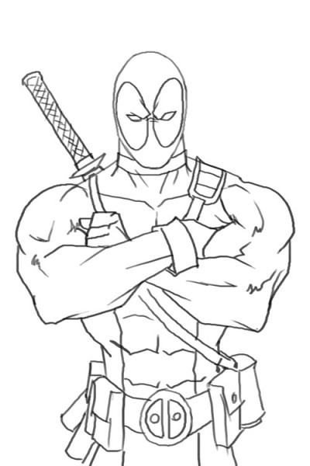

No Reward because DeadPool isn’t worth anything…

but the Hulk would like a few words