Currents Lab
Temperature and salinity affect the density of the water. Ocean salinity differs by small numbers, so oceanographers need to be accurate when measuring salinity. Changes in density caused by wind and currents at the surface affects the deep-ocean currents. Density ultimately affects the objects that are existing in the water, such as whales, seaweed, and submarines. Very salty water is more dense, and will sink more, thus very salty water is found at the bottom. Less salty water is less dense and will float on top of the more dense salty water.

- Surface currents are caused by winds (may also be affected by the earth’s rotation and hitting continents). Surface currents can be:
- WARM (like the Gulf Stream) because they flow from the tropics/equatorial areas
- Or COLD (like the California Current) because they flow from the polar areas
- Deep (or Density) Currents make water rise or sink because of differences in:
- SALINITY
- TEMPERATURE

In today’s lab, you will examine deep/density currents. As you explore different types of water, fill in the diagrams below (to show what happened), then state WHY the water sinks or floats.

Add green salty water Add blue cold water Add red warm water
to clear fresh water to clear warm water to clear cold water

_________________ ________________ _______________
_________________ ________________ _______________
_________________ ________________ _______________
_________________ ________________ _______________
_________________ ________________ _______________
_________________ ________________ _______________

Summary Questions:
- What happened to the drop of very salty green water in the fresh water? Why?

- Which water is denser salty or fresh?

- What happened to the blue cold water in the warm water? Why?

- Which water is denser: warm or cold?

- What happened to the red warm water in the cold water? Why?

- Why is this information important (from questions #1-3)?

- Who would this information be important to?

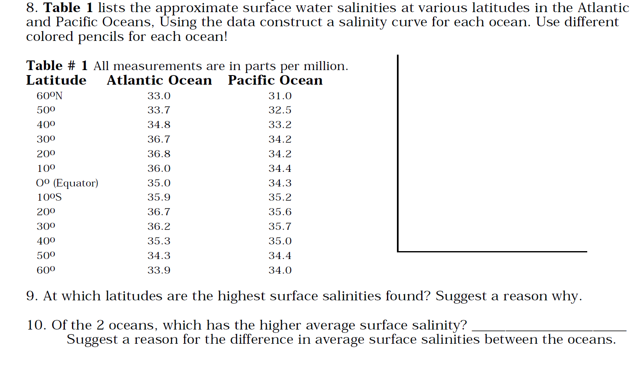

11. Finally, write 1-2 sentences that explains what this lab has to do with deep/density currents.

