Density Notes

If you were told an object has a greater density than another, what would that mean to you?

What is density?

Example 1: Which object has more mass in it? So which one has the most density?

Example 2: Which object has a greater density? Why?

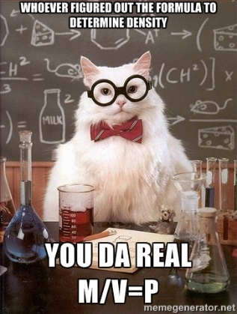
If an object sinks in water, would you say it is more dense or less dense than water? (In the example, which one is MOST dense)?

If you put an object in water that is LESS dense than water, what will happen to that object? Give an example of a liquid that is less dense than water.

How is density calculated? Draw a picture to help you

SAMPLE PROBLEM: What is the density of an object that has a mass of 120 grams and a volume of 5 mL? (Show your work!)

