Deposition

__________________ happens when the wind stops blowing, the water slows down, the glacier retreats or melts, OR when the sediment reaches the bottom of the hill or mountain.

The sediment has no energy to keep it moving, so it drops (deposited). This is a _____________________ force because landforms are created.
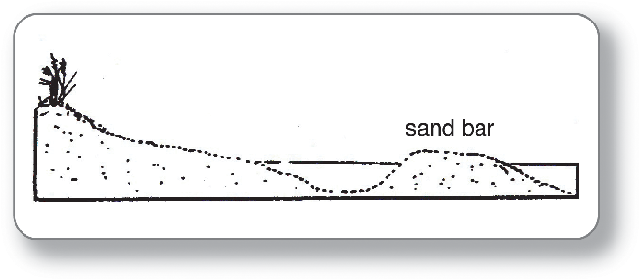
List some landforms created by deposition:
- Beaches
- Sand __________ (may grow to become barrier ________________)
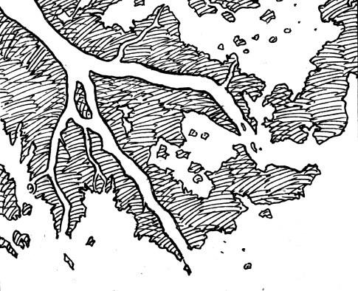
- Barrier __________
- ________________ (beach and deserts)
- ____________ deposits (when glaciers retreat/melt)
- ________________ --at mouth of rivers
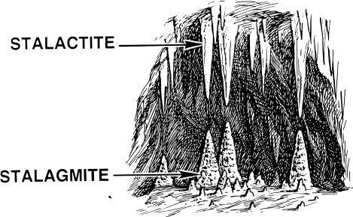
- Alluvial ____________--when river flows from a mountain
- Caves
  - Stalactites (from ceiling)
  - _____________ (from ground)

