Name: _________________________________________________ Date: ________________ Period: __________
The Dust Bowl Assignment
Day 1:
Complete the Inquiry Activity Below:

The visual below represents a catastrophic event that occurred in the United States. A loss was occurring that affected the lives of many people, as well as other living things. Although this photo was taken about 80 years ago, events like this still have the potential to occur. Think about the effects that this catastrophe had on the lives of the people involved as well as the environment in the region.

Effects: __________________________________________________________________________________________________
__________________________________________________________________________________________________________
__________________________________________________________________________________________________________
__________________________________________________________________________________________________________
__________________________________________________________________________________________________________
__________________________________________________________________________________________________________

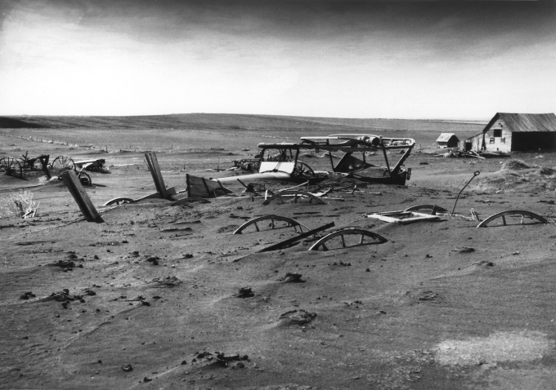

Using your textbook and the text, develop an argument to support the best soil conservation technique that could have been used to conserve the soil in the photograph above. Your argument should include evidence from the text to support your claim.

__________________________________________________________________________________________________________
__________________________________________________________________________________________________________
__________________________________________________________________________________________________________
__________________________________________________________________________________________________________
__________________________________________________________________________________________________________
__________________________________________________________________________________________________________
__________________________________________________________________________________________________________
__________________________________________________________________________________________________________
__________________________________________________________________________________________________________
__________________________________________________________________________________________________________

Day 2:
Answer the following before watching the video clip:
- What do you know about the Dust Bowl?
__________________________________________________________________________________________________________ __________________________________________________________________________________________________________
- What visual pictures come to mind when you think about the United States in the 1930s?
__________________________________________________________________________________________________________
__________________________________________________________________________________________________________

During the video:
- What was the Dust Bowl?
__________________________________________________________________________________________________________

- What climatic weather conditions caused the Dust Bowl?
__________________________________________________________________________________________________________

- What states were directly affected by the Dust Bowl?
__________________________________________________________________________________________________________

- Describe how the people were affected by the Dust Bowl?
__________________________________________________________________________________________________________
__________________________________________________________________________________________________________

- How did people respond to the severe conditions of the Dust Bowl?
__________________________________________________________________________________________________________
__________________________________________________________________________________________________________

After the video:

- If you had been part of one of the farm families in the plains during the 1930s, do you think you would have wanted to stay on your farm or leave?
__________________________________________________________________________________________________________
__________________________________________________________________________________________________________
__________________________________________________________________________________________________________

- List the pros and cons of leaving or staying on your farm during the Dust Bowl Era.
__________________________________________________________________________________________________________
__________________________________________________________________________________________________________
__________________________________________________________________________________________________________
__________________________________________________________________________________________________________
__________________________________________________________________________________________________________

Day 3:
- On a map of the United States identify the states that were most affected by the Dust Bowl. Describe the following information for each state: topography (terrain), general weather patterns, sources of water (river systems), and economic activity (farming, ranching etc.)
__________________________________________________________________________________________________________
__________________________________________________________________________________________________________
__________________________________________________________________________________________________________
__________________________________________________________________________________________________________
__________________________________________________________________________________________________________
__________________________________________________________________________________________________________
__________________________________________________________________________________________________________
__________________________________________________________________________________________________________
__________________________________________________________________________________________________________
__________________________________________________________________________________________________________

- Describe the conditions that created the “perfect storm” for the Dust Bowl to occur in the Great Plains.

__________________________________________________________________________________________________________
__________________________________________________________________________________________________________
__________________________________________________________________________________________________________
__________________________________________________________________________________________________________

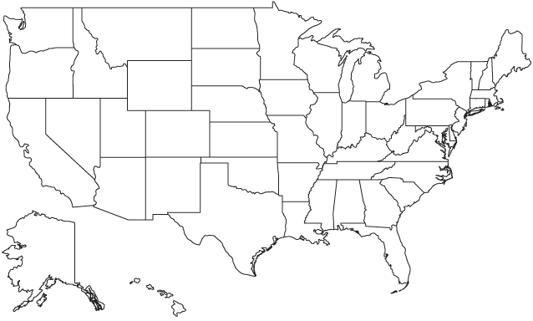
Day 4:
In your group of 4, each person should select a topic from the list below to research. You should be able to effectively and extensively articulate the impact the Dust Bowl had on the following areas in the 1930s:
- Economy (The impact of the Dust Bowl on the local, regional, and national economy. How did the Dust Bowl effect jobs, goods and services, supply and demand etc.?)
- People (The effect on homes (property value), health-dust pneumonia, way of life-Black Blizzards)
- Environment/Land (Land Degradation/Desertification due to over farming; explain how the processes occurred in Great Plains)
- Government- (Governmental Response to the Dust Bowl- New Deal, Soil Conservation Service etc.)

Notes from research:

Notes from other group members about their topic:

