Earth’s Resources study notes:
What is a NATURAL RESOURCE? (look at both words)

What is a renewable natural resource?

Give examples of renewable natural resources:
- trees, wood, paper

What is a nonrenewable natural resource?

Give examples of nonrenewable natural resources:
- rocks and minerals

What are the 3 types of fossils fuels (all NONrenewable resources)?
- ____________ =solid
- ____________ =liquid
- ____________ =gas

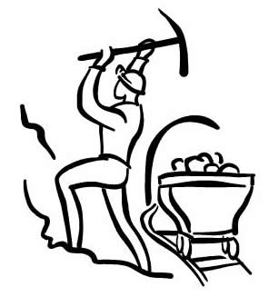
How do we get rocks and minerals from the Earth?

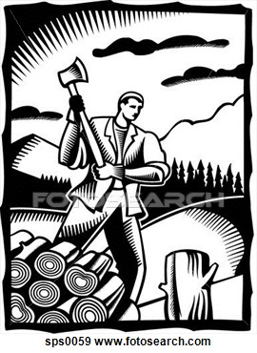
What are some negatives of mining?

>so reduce, reuse, recycle!!!

What are the main differences between minerals and rocks?

Minerals Rocks

