Erosion

Erosion is:
________________ sediments
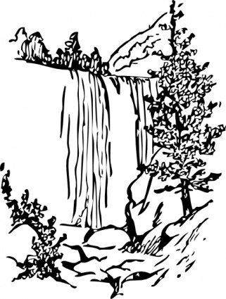
(usually a __________________ force)

The agents of erosion are:
1. MOVING ______________
A. ___________ (surf)
B. runoff (after rain/snow
melt)
C. ____________________
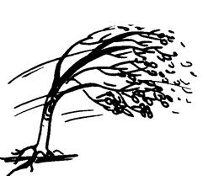
D. ____________________ (can cause caves or sinkholes)
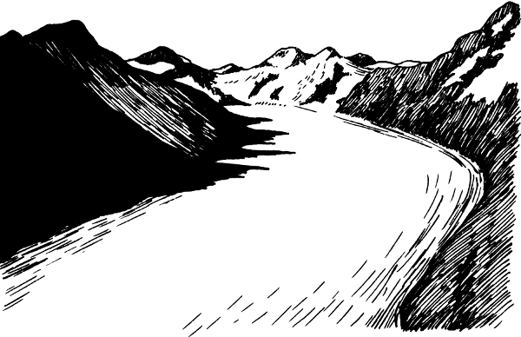
2. _________________
3. Ice (_______________ are slow moving “rivers of moving ice)
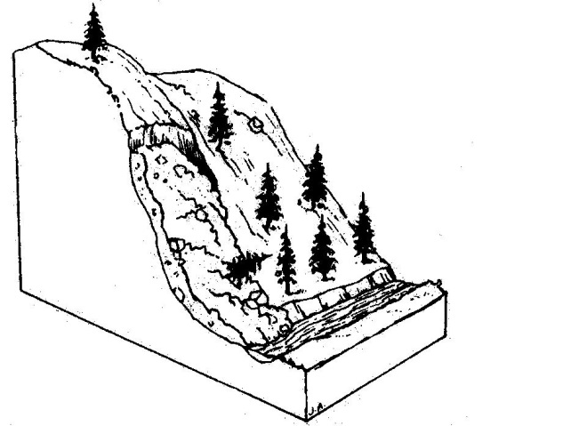
4. Gravity
A. ________________________
B. _________________________
C. avalanches (snow)

