Astronomy- Unit 1 –
Geocentric vs. Heliocentric and Big Bang Notes

Geocentric
- __________ centered
- The __________, ____________, ___________, planets all revolve around the _____________.
- Believed until _______________ AD
- Early cultures (Aristotle) and _____________________.
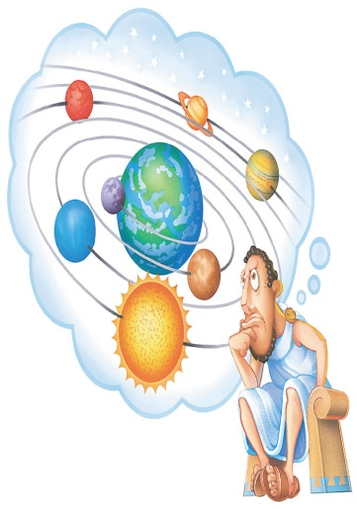
Heliocentric
- ______________ centered
- _______________, _______________ revolve around the _______________.
- Believed from ____________ AD to _______________
- ___________________, Galileo, Kepler and Newton
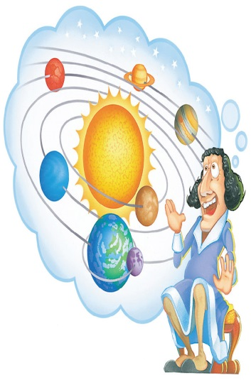

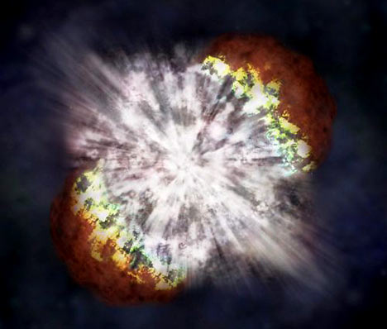
Big Bang Theory
- Theory of the _____________________ of the Universe (theory was made in __________)
- Matter, time and ___________________ were compressed into an extremely tiny ____________ (very unstable)
- EXPLODED about _____________________________ years ago.

Preview Questions:
- What made Galileo believe in Copernicus’ theory of the solar system? ________________________
- What causes seasons? ______________________________________________________________
- One rotation of the Earth takes how many hours? ________________________________________
- What is the shape of the Earth’s orbit around the sun? ____________________________________
- One revolution of the Earth around the Sun takes how many days? __________________________
- What two forces allow the Earth to orbit around the Sun? _________________________________

