Name: ___________________________________________________ Date: ______________________ Period: _______
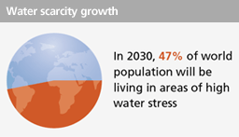
Global Water Crisis
In 2030, 47% of world population will be living in areas of high water stress. Most population growth will occur in developing countries, mainly in regions that are already experiencing water stress and in areas with limited access to safe drinking water and adequate sanitation facilities. Water resource management impacts almost all aspects of the economy, in particular, health, food production and security, domestic water supply and sanitation, energy, industry and environmental sustainability.
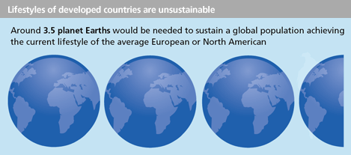

Humans are over-consuming natural resources at an unsustainable rate. Around 3.5 planets Earth would be needed to sustain a global population achieving the current lifestyle of the average European or North American.
Water scarcity already affects almost every continent and more than 40 percent of the people on our planet. By 2025, 1.8 billion people will be living in countries or regions with absolute water scarcity, and two-thirds of the world’s population could be living under water stressed conditions.
Activity 1 Part 1
- Before watching the video, do you think people will need more or less freshwater in the future? Why?
________________________________________________________________________
________________________________________________________________________
- Write down two things that surprised you from the video
________________________________________________________________________
________________________________________________________________________

- Before watching the next video, why is water specifically freshwater, so important?
________________________________________________________________________
________________________________________________________________________

- Describe one thing YOU can do to ensure people have fresh drinking water.
________________________________________________________________________
________________________________________________________________________

What is causing the Water Crisis?
What is causing the water crisis? Is this a natural cause or an unnatural cause? You will discuss this very question in class for a grade. It is up to you to collect information about why you think we are having a water crisis. You will need to read at least three articles to collect your data and major points to share with the class on Monday.
Article 1 Title: ___________________________________________________

Article 2 Title: __________________________________________________

Article 3 Title: _________________________________________________

