Name: _____________________________________________ Date: _____________________ Period:___________
Global Winds Questions
Take a trip around the room (where ever the wind takes you… get it!) and answer the questions as you go. If you want to look at the questions later on, you can go to Ms. Dudek’s blog and look at the hand-out.

- A B C D
- A B C D
- A B C D
- A B C D
- A B C D
- A B C D
- A B C D
- A B C D
- A B C D
- A B C D
- A B C D
- A B C D
- A B C D
- A B C D
- A B C D
- A B C D
- A B C D
- A B C D
- A B C D

- ___________________________________________________________________________________________
___________________________________________________________________________________________
___________________________________________________________________________________________
- A B C D
- ___________________________________________________________________________________________
___________________________________________________________________________________________
___________________________________________________________________________________________
Jet Streams
Read the 3 paragraphs on the back of this sheet, then answer the questions below.
- Which temperature zone of the atmosphere is the polar jet stream located in? ________________

- What does the term meandering mean? ______________________________________________

- For the eastern United States, the change of the polar front jet stream from this summer position to this winter position causes
  - warmer temperatures farther north and causes storms to move more slowly
  - warmer temperatures farther north and causes storms to move more rapidly
  - cooler temperatures farther south and causes storms to move more slowly
  - cooler temperatures farther south and causes storms to move more rapidly

- A pilot is traveling from New York to California during the winter. Why would the pilot want to avoid the jet stream on his trip?

Jet streams are fast flowing, narrow air currents found in the atmosphere. The major jet streams on Earth flow from west to east. Their paths typically have a meandering shape. The strongest jet streams, the polar jets, are found at an altitude of 9 to 11 kilometers above sea level. Jet streams form due to a combination of two factors. The first factor that contributes to the formation of the jet stream is Earth’s rotation. The second factor that contributes to the jet stream is the temperature difference between two adjacent air masses.
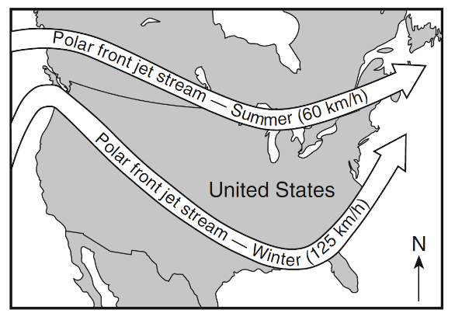
The seasons on Earth contribute to the path the jet stream will take. Jet streams are more active in the winter because there are wider differences in the temperatures between the cold Arctic air mass and the warm tropical air mass. The temperature difference also influences the speed of the air in the jet stream. The greater the temperature difference between the two air masses, the faster the air moves in the jet stream. The map below shows a typical position and average velocity of the polar front jet stream during different seasons.

The jet streams have a major impact on our life on Earth. Firstly, meteorologists use jet streams to help predict the weather because the jet streams push air masses and weather systems to new areas. Also, air travel is influenced by the jet stream. Airplanes that are traveling east can fly in the jet stream. Since the air in the jet stream moves so fast, the airplane can fly faster and save fuel by flying in the jet stream.

