Name: Date:
Earth Science: Period:
Global Wind Patterns

- Which factor causes global wind patterns?
  - changes in the distance between Earth and the Moon
  - unequal heating of Earth’s surface by the Sun
  - daily changes in the tilt of Earth’s axis
  - rapid rotation of the Sun on its axis

- Which statement best explains how the Coriolis effect influences weather conditions?
a. It causes winds to rotate, forming tornadoes on Earth.
b. It causes winds to move to the right in the Southern Hemisphere.
c. It causes winds to turn to the right in the Northern Hemisphere.
d. It causes winds to follow a straight-line path around Earth.

Base your answers to questions 3 through 6 on the map below, which shows Earth’s planetary wind belts.

- The curving of these planetary winds is the result of
- Earth’s rotation on its axis
- the unequal heating of Earth’s atmosphere
- the unequal heating of Earth’s surface
- Earth’s gravitational pull on the Moon

- Which wind belt has the greatest effect on the climate of New York State?
- prevailing northwesterlies c. northeast trades
- prevailing southwesterlies d. southeast trades

- The trade winds between 30˚S and the equator usually blow from the
  - northeast b. southeast c. northwest d. southwest

- Which climatic conditions exist where the trade winds converge?
- cool and wet c. warm and wet
- cool and dry d. warm and dry
- Which map best shows the surface movement of winds between 30˚N and 30˚S latitude?
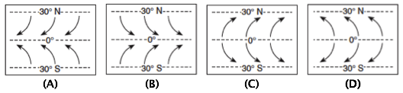

Base your answers to questions 8 through 10 on the diagram below, which represents the planetary wind and moisture belts in Earth’s Northern Hemisphere.

- The climate at 90˚ north latitude is dry because the air at that location is usually
  - warm and rising c. cool and rising
  - warm and sinking d. cool and sinking

- The paths of the surface planetary winds are curved due to Earth’s
  - revolution c. circumference
  - rotation d. size

- The tropopause is approximately how far above sea level?
  - 12 mi c. 60 mi
  - 12 km d. 60 mi

- The prevailing winds at 45˚S latitude are from the
- southwest c. southeast
- northwest d. northeast

- At which latitudes do currents of dry, sinking air cause the dry conditions of Earth’s major deserts?
- 0˚ and 30˚N
- 60˚N and 60˚S
- 30˚N and 30˚S
- 60˚S and 90˚S

- Snowfall is rare at the South Pole because the air over the South Pole is usually
- rising and moist c. sinking and moist
- rising and dry d. sinking and dry

- The planetary wind and moisture belts indicate that large amounts of rainfall occur at Earth’s Equator because air is
- converging and rising c. diverging and rising
- converging and sinking d. diverging and sinking

- The prevailing southwesterlies wind belt causes most low-pressure weather system to travel across the United States from the
- southwest toward the northeast
- northwest toward the southeast
- northeast toward the southwest
- southeast toward the northwest

- Which graph best shows the average annual amounts of precipitation received at different latitudes on Earth?
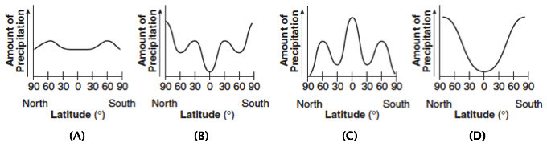

- The map below shows an imaginary continent in the Earth’s planetary wind belt between 30˚ and 60˚ North latitude. Location P is on the western edge of the continent.
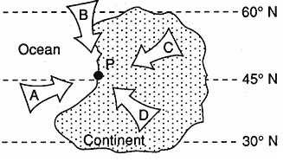
Location P has mild winters with much precipitation. Which arrow indicates the direction of the prevailing winds at this location?
- A c. C
- B d. D

- The diagram below represents wind patterns on Planet X.
Where would deserts most likely be found on Planet X?
a. A b. B c. C d. D
- The following map shows the location of a hurricane in the Gulf of Mexico at 17˚N, 81˚W.
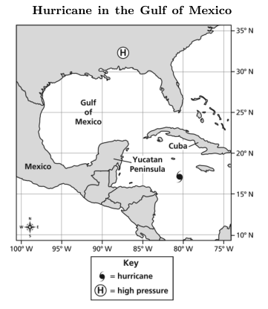
Which of these describes the likely outcome for this hurricane?
- The rotation of Earth will force the hurricane to the southeast, where it will make landfall.
- The dry land surrounding the hurricane will absorb moisture from the hurricane, causing it to break apart.
- Strong trade winds will blow the hurricane across the Yucatan Peninsula toward Mexico, where it will make landfall.
- Strong ocean currents moving from the equator to the north will push the hurricane into Cuba, where it will break apart into many smaller storms.

- The map below shows the location of a hurricane in the Atlantic Ocean at 29˚N, 72˚W.
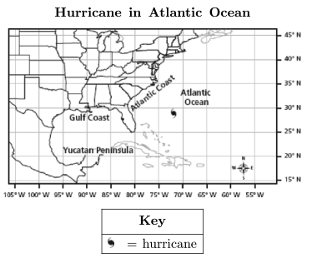
The hurricane has been moving toward the northwest at a rate of 30 miles per hour. When the hurricane passes 30˚N, which direction should it start moving toward? Explain your answer.

- The diagram below illustrates the motion of prevailing winds over oceans on Earth.
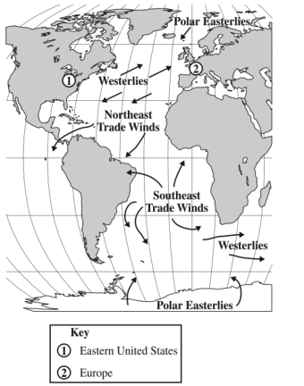
If a sailboat sailed from the eastern United States to Europe, and then back, which of the following winds would most directly power the sailboat?
a. Polar Easterlies going and Westerlies returning
b. Northeast Trade Winds going and Westerlies returning
c. Westerlies going and Northeast Trade Winds returning
d. Southeast Trade Winds going and Northeast Trade Winds retuning

- The map below shows the movement of a hurricane in the Pacific Ocean. The hurricane symbol represents the location of the hurricane each day for 7 days.
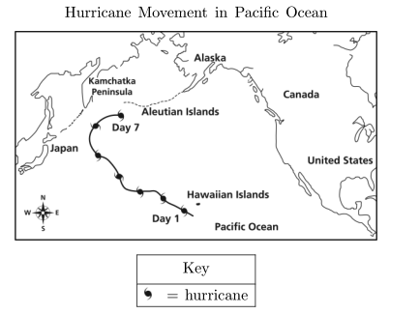
Explain the most likely reason the hurricane changed direction between day 5 and 6.

Base your answers to questions 23 through 26 on the information below about jet streams.

Jet Streams

Jet streams are fast flowing, narrow air currents found in the atmosphere. The major jet streams on Earth flow from west to east. Their paths typically have a meandering shape. The strongest jet streams, the polar jets, are found at an altitude of 9 to 11 kilometers above sea level. Jet streams form due to a combination of two factors. The first factor that contributes to the formation of the jet stream is Earth’s rotation. The second factor that contributes to the jet stream is the temperature difference between two adjacent air masses.

The seasons on Earth contribute to the path the jet stream will take. Jet streams are more active in the winter because there are wider differences in the temperatures between the cold Arctic air mass and the warm tropical air mass. The temperature difference also influences the speed of the air in the jet stream. The greater the temperature difference between the two air masses, the faster the air moves in the jet stream. The map below shows a typical position and average velocity of the polar front jet stream during different seasons.
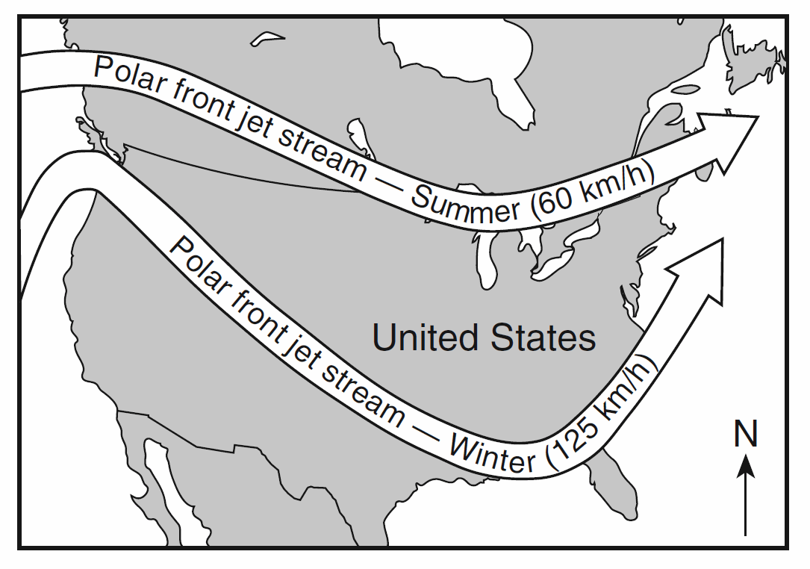
The jet streams have a major impact on our life on Earth. Firstly, meteorologists use jet streams to help predict the weather because the jet streams push air masses and weather systems to new areas. Also, air travel is influenced by the jet stream. Airplanes that are traveling east can fly in the jet stream. Since the air in the jet stream moves so fast, the airplane can fly faster and save fuel by flying in the jet stream.

- Which temperature zone of the atmosphere is the polar jet stream located in? ________________

- What does the term meandering mean? ______________________________________________

- For the eastern United States, the change of the polar front jet stream from this summer position to this winter position causes
  - warmer temperatures farther north and causes storms to move more slowly
  - warmer temperatures farther north and causes storms to move more rapidly
  - cooler temperatures farther south and causes storms to move more slowly
  - cooler temperatures farther south and causes storms to move more rapidly

- A pilot is traveling from New York to California during the winter. Why would the pilot want to avoid the jet stream on his trip?

