Name: _________________________
GROUNDWATER NOTES
Important Components to Making Groundwater:
Zone of Aeration: area that adds ________________ into the water
Zone of Saturation: area that adds ______________ into the water
Water table: the _____________ surface of underground water
Impermeable Rock: rocks and soil that are really close together which ______________ the water
Recharge area: surface water that comes down into the ground and reaches the ___________________________ and is able to enter the aquifer.
LABEL THE FOLLOWING:
- Aquifer
- Water table
- Impermeable layer
- Zone of saturation
- Zone of aeration
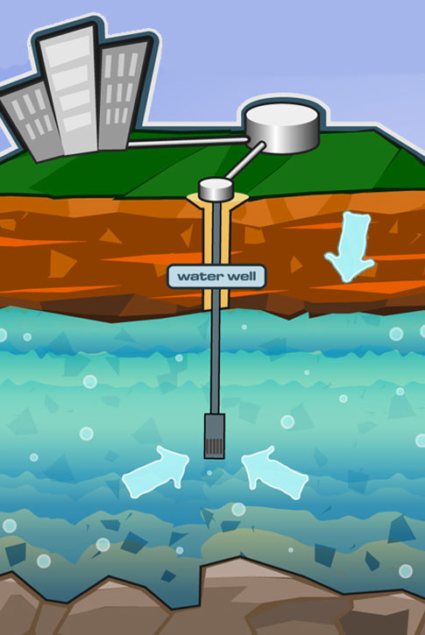
- Recharge area

What are aquifers and why are they important?
How do aquifers get their water?
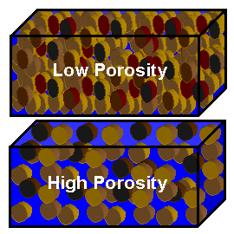
Porosity: the amount of ______________ spaces
This is due to the _________ of particles
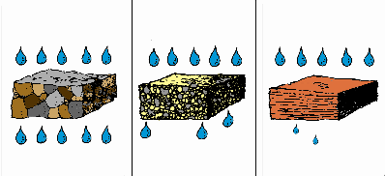
Permeability: rock’s ________________ to let water pass through.
Impermeable = rocks that ____________ the flow of water

What’s up with U.S and their groundwater??

Can pollution of groundwater happen? If so, what is it called?

Groundwater can also form _______________. This is formed by __________________ weathering.
Stalagmites come from the ______________
Stalactites come from the _________________
Groundwater can form __________________. This is because the _____________________________ lowers in a cave.
REVIEW:
What describes an aquifer’s ability to allow water to flow through?
A ________________ is the upper surface of the zone of saturation.
A watershed is a region of land _____________________________________________.
When does a sinkhole form?

