HOW TO USE A METRIC RULER
The standard unit for measurement of length in the metric system is the meter. In science class, most measurements are much smaller than a meter. A metric ruler is the standard instrument for measurement in the scientific laboratory. On a metric ruler, each individual line represents a millimeter (mm). The numbers on the ruler represent centimeters (cm). There are 10 millimeters for each centimeter. To read a metric ruler, each individual line represents .10 (1/10) of a centimeter, or 1 millimeter.
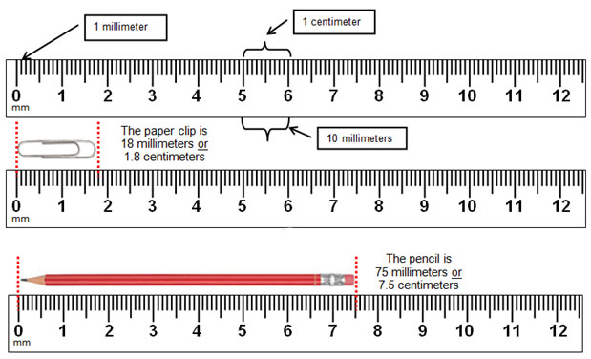
Notice when converting from centimeters to millimeters, the decimal point is moved one place to the right. To convert millimeters to centimeters, move the decimal point one place to the left.

