Name _____________________________ |  |  | Date ___________________
Inequalities
Use substitution to determine whether the value given for the variable makes the inequality true or false.
SHOW YOUR WORK!! (NO WORK SHOWN = NO CREDIT!)
1. 15 - m 4 m = 11 | 2. 15 a 10 a = 153 | 3. 8 > 64 r r = 16
4. 76 19h h = 4 | 5. 22 < 19 + q q = 5 | 6. 124 15z z = 5
7. 2v > 24 v = 12 | 8. n 5 < 16 n = 57 | 9. 72 e < 12 e = 17
10. 29 - u 9 u = 20 | 11. a + 16 > 30 a = 14 | 12. 38 > 32 + z z = 13
13. 16 - j < 3 j = 13 | 14. 21 7r r = 3 | 15. 10h 62 h = 11
16. 30 k 6 k = 3 | 17. 28 + d > 37 d = 6 | 18. 17 w 4 w = 78
19. 15 22 - g g = 19 | 20. 18r < 198 r = 12 | 21. e 7 < 10 e = 22

Write the inequality represented by each graph below:
Figure 1 - ______________________________
-1 0 1 2 3 4 5

6 7 8 9 10 11

25 26 27 28 29 30

0 10 20 30 40 50

Figure 2 - ______________________________

Figure 3 - ______________________________

Figure 4 - ______________________________

Write the inequality AND graph for each problem below:
1) Mrs. Bothers’ kids will go trick-or-treating at more than 100 houses on Halloween.

2) Mrs. Bothers will eat at least 20 candies from her kids’ stash after they go to bed.

3) The temperature is supposed to be below 45⁰ on Wednesday night.

4) Last year, no more than 30 trick-or-treaters came to Mrs. Bothers’ house.
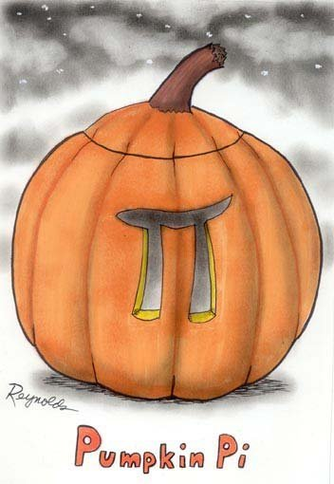

5) There are more than 200 candies in the bag I bought today.

