Inside the Earth Guide
How do scientists know what is inside the Earth?

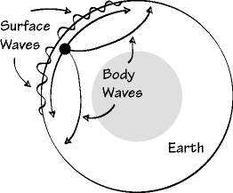
***Temperature and pressure __________________ as you get deeper into the earth!

LABEL THE 4 LAYERS IN THE PICTURE below:

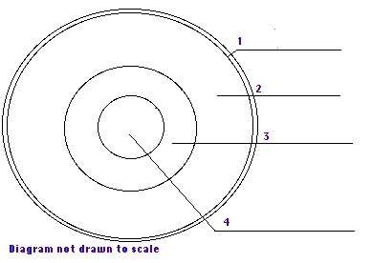

CRUST (SOLID rock, mountains & soil):
_____________________ layer (skin)
Thinnest under _______________(5 km)
Thickest under _______________(100 km)
Temp: near freezing to __________ °C
Two types of crust:
- ________________ (basalt)
- ________________ (granite)
Circle above which type of crust is MOST dense.
In the diagram below, label the continental and oceanic crust:
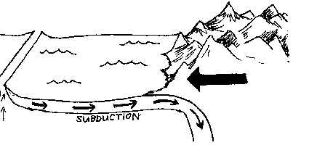
MANTLE (HOT/bendable ROCK!):
About _______________ km thick (thickest/largest of the 4 layers)
Why is the mantle DENSER than the crust?

Temp: _________ °C to ____________ °C
Note: very top of mantle is ____________

CORE (inner layer):
Mostly made of __________ and nickel (very dense metals—so densest layer)
What are the two parts of the core?
- 1. _____________ core (liquid metal)
--temp: _______________________°C and about 2250 km thick
- 2. _____________ core (_______ metal because of the ____________)
--temp: 5000--______________°C and about ________ km thick
SO WHAT DOES THIS HAVE TO DO WITH PLATE TECTONICS?
Two parts of the earth:
- ____________sphere—the SOLID/rigid outer part of earth (___________ and upper mantle)—this part of the earth is broken into tectonic ___________
- _____________sphere—the soft, thick LIQUID/hot plastic-like part of mantle (flows slowly)
The lithosphere ____________ on the asthenosphere.
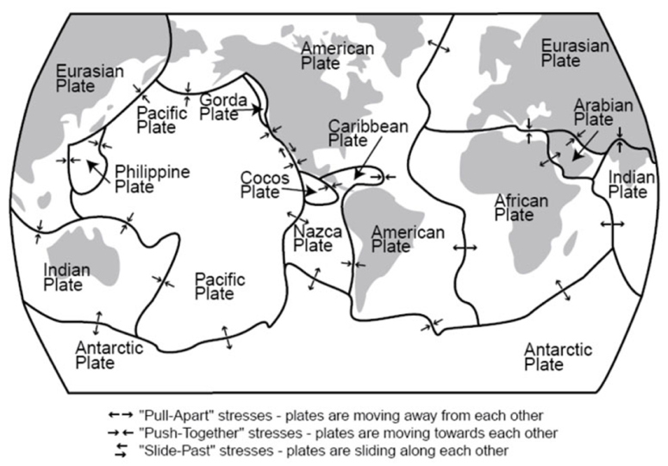
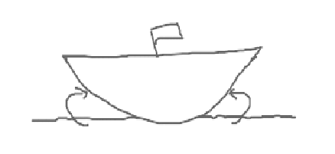

How does heat move around (heat transfer)?
- ____________________--heat from sun
- _____________________--from touching
- **________________________
  - warm (less dense) ______________
  - cold (more dense) ______________
Where does the convection heat come from?

Lithospheric is divided into 10 major tectonic plates (most contain oceanic and continental crust).
Example: we live on the __________________________________ plate
What’s so interesting about California? (Label where it is located)

