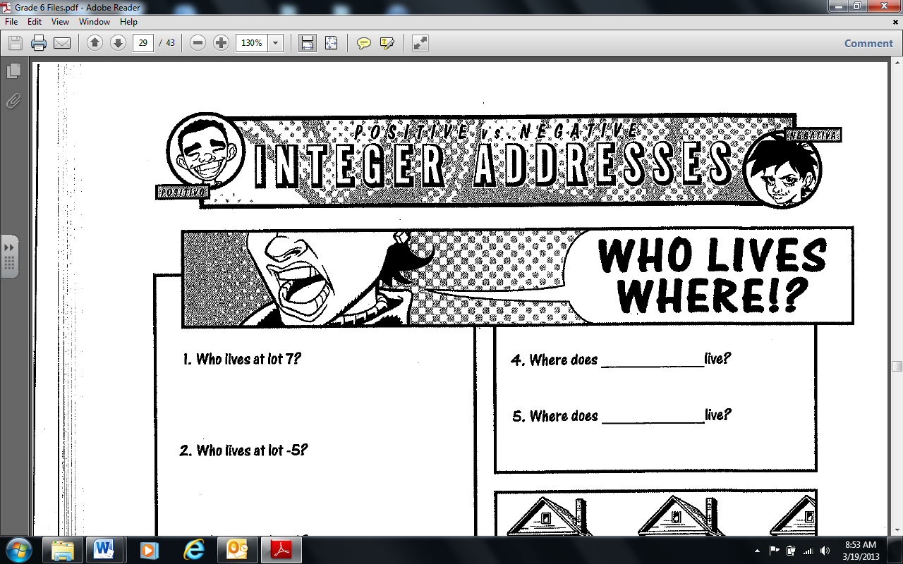

For each question, name the lot owner and the address.

1. Who lives six lots from Central Park? ____________________ and _______________________
2. Who lives three lots from Central Park? ____________________ and _____________________
3. Who lives seven lots from Central Park? ___________________ and ______________________
4. Who lives nine lots from Central Park? ____________________ and _______________________
5. Why are there two answers for questions 1 – 4? _______________________________________

__________________________________________________________________________

1. Who lives three lots from lot 5? _____________________ and _______________________
2. Who lives four lots from lot 2? _____________________ and _______________________
3. Who lives two lots from lot -6? _____________________ and _______________________
4. Who lives five lots from lot -1? _____________________ and _______________________
5. What patterns do you notice in each of the two answers for questions 6 – 9? _________________

___________________________________________________________________________

1. How far apart are lots 8 and 9? _______________
2. How far apart are lots -7 and 2? _______________
3. How far apart are lots -4 and 3? _______________
4. How far apart are lots 8 and -2? _______________
5. How far apart are lots -9 and -2? _______________
6. Without using your number line, predict how far apart lots -21 and -16 would be. ______________ Predict how far apart lots -25 and 25 would be. ______________________ Explain how you determined these answers. _______________________________________________________  
   ___________________________________________________________________________
7. What directions would you give to get from lot 9 to lot 5? ________________________________
8. What directions would you give to get from lot 3 to -2? _________________________________
9. What directions would you give to get from -4 to 1? ____________________________________
10. What directions would you give to get from -7 to -1? ____________________________________
11. Who lives at the destination given by following the directions: 4 – 6 = ? ______________________
12. Who lives at the destination given by following the directions: -2 – 5 = ? _____________________
13. Who lives at the destination given by following the directions: -3 + 8 = ? _____________________
14. Who lives at the destination given by following the directions: -5 + 6 = ? _____________________

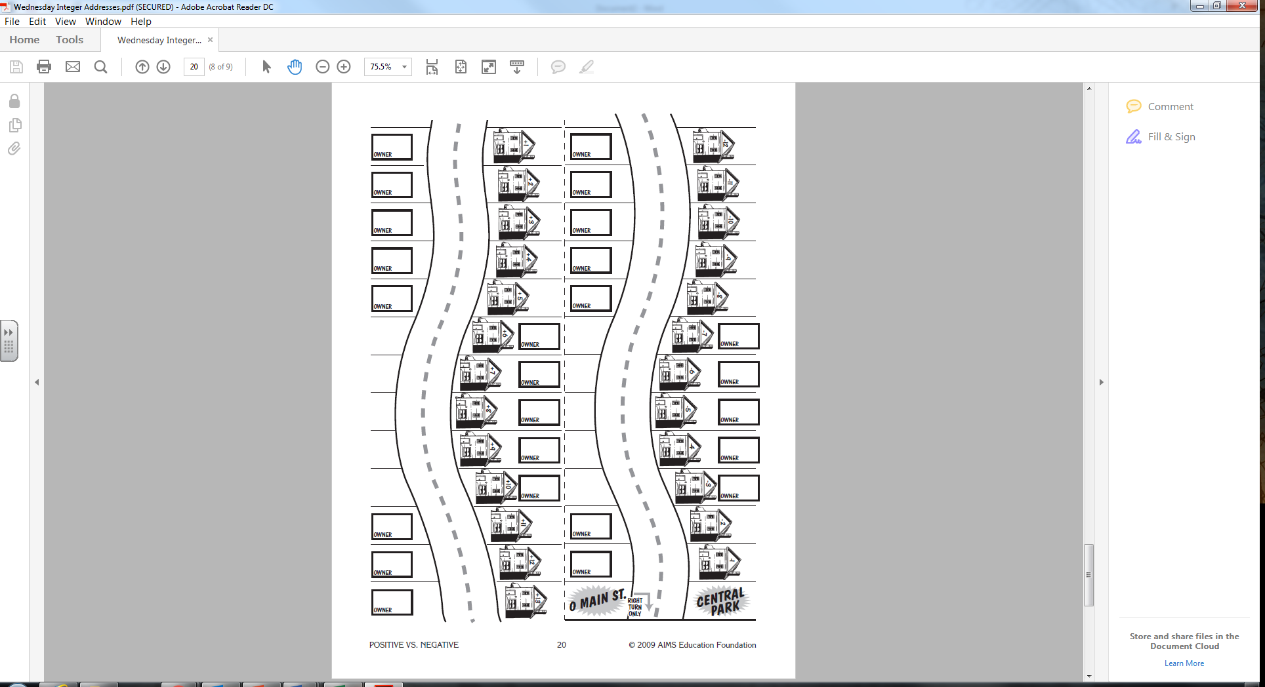

Oprah

Jamie Foxx

Adele

Iggy Azalea

Jennifer Lopez

Buzz Lightyear

Spongebob

Scooby Doo

Donald Duck

Goofy

Minnie Mouse

Mickey Mouse

Hello Kitty

Justin Bieber

Selena Gomez

Batman

Superman

Wonder Woman

The Hulk

Spiderman

Rihanna

Beyonce

Jay Z

Taylor Swift

Katy Perry