Intro to Rocks Guide
A rock is a _____________________ of ____________________________. (example: granite is made of 3-4 minerals)
Geologists (scientists who study rocks) classify & identify rocks according to their…
Rocks are classified by
1.
2.
3.
- MINERAL TEXTURE:
  - Grain ______________
- ___________-grained (can be seen without a microscope)
- ___________-grained (microscopic)
- No grains—glassy because no crystals formed
  - Grain ____________—smooth or jagged
  - Grain ____________—wavy; flat
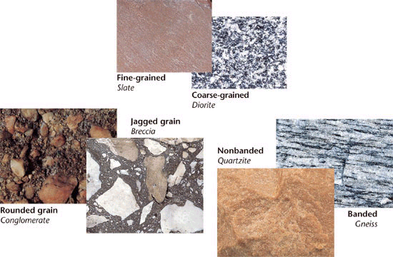

2. MINERAL __________________________ (what the rock is made of)
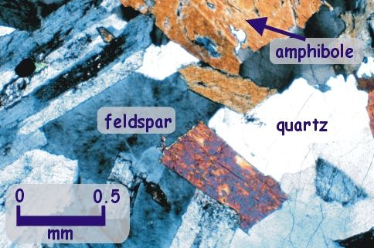

3. ORIGIN of rock (where and how did the rock ________________?):
- Igneous Rock:
>How do they form?

>examples:

- Sedimentary Rock: (most of the rocks on Earth are sedimentary)
>How do they form?

>List 3 examples of sediment (in green):

>examples of sedimentary rock:

(some sedimentary rock have __________ from extinct animals/plants---paleontology)
- Metamorphic:
>How do they form?

>examples:

