Name: __________________________________________ Date: _________________ Period: ________________
Lab Safety Project
Due Wednesday, August 8th
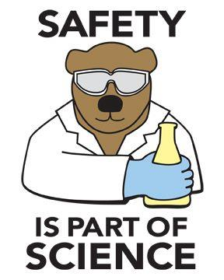
You have just started Middle School Earth Science! It is so exciting to know that you will be doing labs all the time now. The only problem is that your classmates may not know the rules to follow during a lab. Your task is to create a visually appealing poster/meme/saying/anything else to display around the room or hallway! East Cobb doesn’t just want any ordinary poster listing the rules, this school is full of creativity and we want to show it off!
Your grade will be determined by the following criteria:
Creativity/Originality 40%
Neatness 30%
Accuracy of Rule 30%
FINAL GRADE: ________________________
Name: __________________________________________ Date: _________________ Period: ________________
Lab Safety Project
Due Wednesday, August 8th
You have just started Middle School Earth Science! It is so exciting to know that you will be doing labs all the time now. The only problem is that your classmates may not know the rules to follow during a lab. Your task is to create a visually appealing poster/meme/saying/anything else to display around the room or hallway! East Cobb doesn’t just want any ordinary poster listing the rules, this school is full of creativity and we want to show it off!
Your grade will be determined by the following criteria:
Creativity/Originality 40%
Neatness 30%
Accuracy of Rule 30%
FINAL GRADE: ________________________

