MAY 18th:
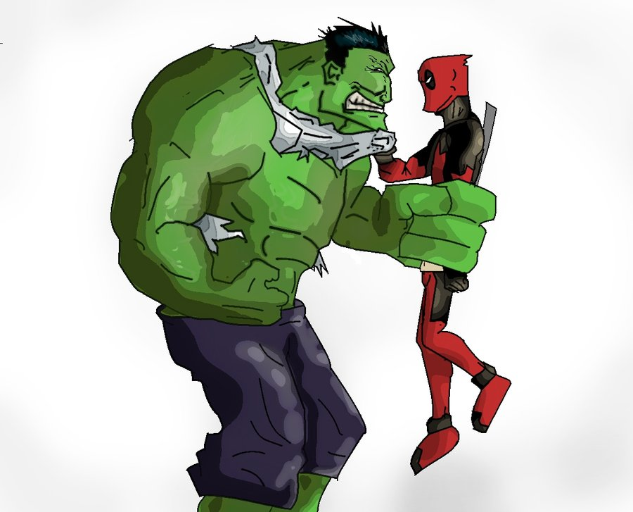
Let the Games Begin

