Name: ______________________________________________________________________________ Date: _______________ Period: ________________
Mapping Finding Nemo
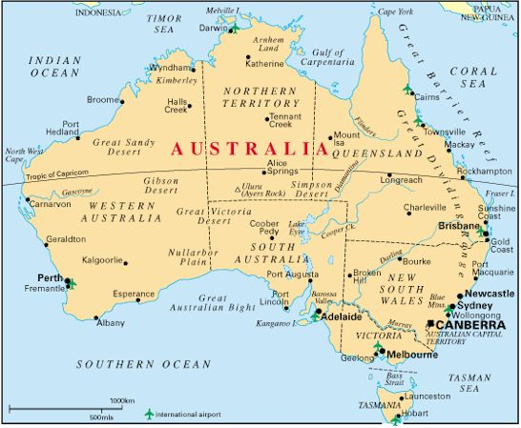
Have you ever wondered how accurate Finding Nemo actually is? Maybe not, but we will see if it is truly something that could happen. Answer the questions below and begin mapping where each scene may take place.
- Draw a picture that looks like a house where you think Nemo and Marlin live. Do you think this is realistic? Why or why not?
____________________________________________________________________
____________________________________________________________________

- Write “CLIFF” where you think the drop off is located. Do you think this is realistic? Why or why not?
____________________________________________________________________
____________________________________________________________________

- Draw a picture of a boat where you think nemo touched the “butt”. Do you think this is realistic? Why or why not?
____________________________________________________________________
____________________________________________________________________

- Draw a dotted line of where you think the boat went with Nemo. Do you think this is realistic? Why or why not?
____________________________________________________________________________________________________________________________

- Draw a blue fish where you think Marlin initially met up with Dory. Do you think this is realistic? Why or why not?
____________________________________________________________________________________________________________________________

- Draw three sharks and a sunken ship where you think this happened. Do you think this is realistic? Why or why not?
____________________________________________________________________________________________________________________________

- Draw goggles where you think Dory dropped them into the deep trench. Do you think this is realistic? Why or why not?
____________________________________________________________________________________________________________________________

- Draw a jellyfish where you think Dory and Marlin run into the large school of them. Do you think this is realistic? Why or why not?
____________________________________________________________________________________________________________________________

- Draw a picture of a turtle where you think Dory and Marlin initially met Crush/Squirt. Do you think this is realistic? Why or why not?
____________________________________________________________________________________________________________________________

- Draw a dotted line of the path that you think they take with Crush and Squirt. Do you think this is realistic? Why or why not?
____________________________________________________________________________________________________________________________

- Draw a whale where you think they come in contact with the whale first. Do you think this is realistic? Why or why not?
____________________________________________________________________________________________________________________________

- Draw a dotted line to where you think the whale took Marlin and Dory. Do you think this is realistic? Why or why not?



