Name: _____________________________________________ Date: ________________ Period: ______________
Mineral Investigation
Part 1:
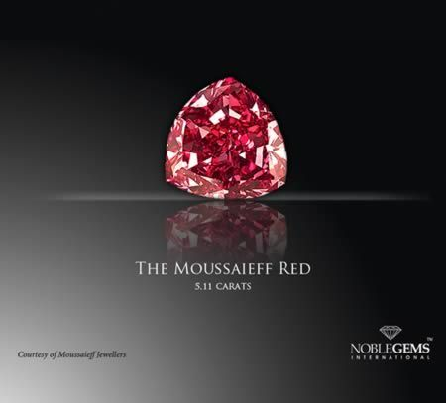
Science Phenomenon: Red diamonds are the most expensive minerals in the world, with a price tag of over $1 million per carat. There are less than 30 of them found around the world, with most of them being less than half a carat. The famous 5.11ct Moussaieff Red Diamond was acquired in 2011 for $8 million and is the largest red diamond discovered in the world. Science
Investigation Purpose: You have been hired by the Know-Whin Investment Corporation to determine the value of a mineral deposit located on a piece of land they are considering buying. The Corporation has supplied you with six bags of mineral samples their agents have collected from the land. Your task is to determine the identity of each of the six minerals. Then you will research how valuable each mineral is and report back to the corporation giving your recommendation about whether they should buy the land.
- Name some minerals you are familiar with: __________________________________________________
___________________________________________________________________________________________
- Why do companies mine minerals? _________________________________________________________
___________________________________________________________________________________________
- Why are some minerals valuable while others are not? ______________________________________
___________________________________________________________________________________________
Part 2:
How could you design an experiment to identify a bag of minerals? Explain below by LISTING steps. (Hint: There are at least 8 different steps)

Part 3 (after the mineral identification lab):
Why can the properties of minerals be used to identify mineral samples? ____________________________
__________________________________________________________________________________________________
__________________________________________________________________________________________________
__________________________________________________________________________________________________
Part 4:
To: Student Mineralogists
From: Know-Whin Investment Corporation
RE: Potential Land Purchase
Dear Mineralogists,
The team of professional excavators we hired determined that the piece of land in question contains the following quantities of minerals:

Calcite: 25,000 kg
Quartz: 30,000 kg
Fluorite: 15,000 kg
Apatite: 500 kg
Gypsum: 100,000 kg
Pyrite: 2,000 kg

If we have to pay $10,000,000 for the land and the average cost of mining 1 kg of minerals is $2.50, should we buy the land? Please respond with an argument for why we should or should not mine, including as much evidence as possible, as well as your reasoning.
Thank you,
Know-Whin Investment Corporation
Research the price/value of each of the minerals above. The price might be listed per pound, carat, or ton of minerals. Here are some helpful conversions for you to use:

1 kg = 5,000 carats
1kg = 2.2 pounds
1 ton = 907 kg

Mineral | Price per unit | Math Conversion | Total Profit Potential
Calcite | $40 per ton
Quartz | $20 per kg
Fluorite | $30 per 5,000 carats
Gypsum | $2.50 per kg
Pyrite | $4.50 per pound
Apatite | $75 per carat
Cost analysis: Total profit – (cost of property + cost of mining) = _________________________
__________________ - ( _________________ + _______________ ) = __________________________
Part 5:
Write a letter back to the Know-Whin Corporation using claim, evidence, and reasoning to argue FOR and AGAINST the purchase of the land, citing evidence.

KEY:

Mineral | Price per unit | Math Conversion | Total Profit Potential
Calcite | $40 per ton |  | $1,000
Quartz | $20 per kg |  | $600,000
Fluorite | $30 per 5,000 carats |  | $450,000
Gypsum | $2.50 per kg |  | $250,000
Pyrite | $4.50 per pound |  | $19,800
Apatite $75 per carat $187,500,000
Cost analysis: Total profit – (cost of property + cost of mining) = _________________________
$188,820,800 - ($10,000,000 + $431,250) = $178,389,550

*Challenge: if it takes $3,500 per acre to ‘reclaim’ the land after mining, how many maximum acres could the land be?

- Take out the test materials and minerals and organize them.
- Pick a mineral and examine it’s color by using your eyes.
- Test streak by rubbing the mineral on the white streak plate. If the streak color is white, test it on your desk.
- Test special properties with magnet to see if mineral is magnetic. Then test acidity with acid.
- Test hardness by completing the following:
  - Scratch fingernail. If it scratches it is harder than 2.5 then continue.
  - Scratch copper. If it scratches it is harder than a 3 then continue.
  - Scratch glass. If it scratches it is harder than 5.5-6.
- Test luster by putting it under a light to see if it shines.
- Test density by weighing it in your hand (mass/volume).
- Test crystal structure by looking at it with a magnifying glass.
- Test breakage by looking at it to see if it has cleavage (smooth faces) or fracture (jagged).
- Repeat with all minerals.

