Name: _________________________________________________________________ Date: ____________________________ Period: ________________
My Life as a Drip Comic
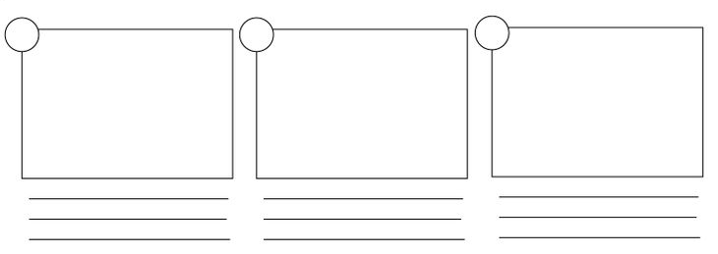
Create a comic to explain your drips progression through the water cycle. Your drip MUST go through each of the following processes: evaporation/transpiration, condensation, precipitation (specify which type of precipitation), and runoff/infiltration. Be creative! You will use this to write your story on the back. Try to design your comic where someone would be able to look at it and know your story.

