Notes Air Pressure: Air Pressure
- As you increase______________________, air pressure, density, and temperature __________________

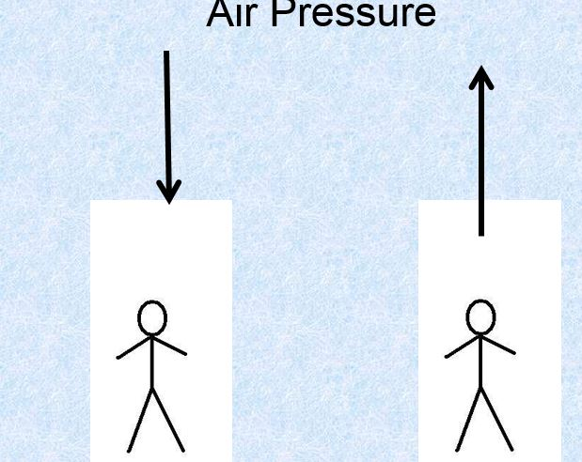

- ___________ air rises, creating _____________ (clouds form if enough moisture)

- ___________ air sinks, creating _____________ (results in few or no clouds)

- __________________= “lousy” weather

- ___________________= “happy” weather

- Instrument= ____________________(2 types)—aneroid* and mercury

- high pressure
  - ________________________________
  - ________________________________
  - ________________________________
- Low Pressure
  - ________________________________
  - ________________________________
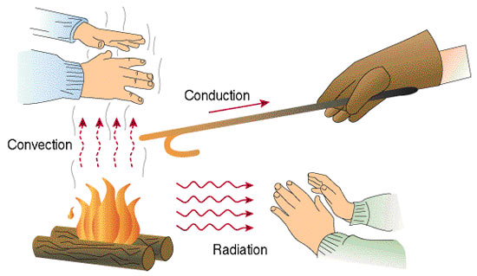
  - ________________________________

Heat Transfer

- _____________________How heat travels from one place to another…

- Only about _____________________ of the sun’s energy actually reaches Earth!!!

- Radiation

  - ___________________ from the sun
  - travels in __________________________ (EM) waves
  - Example:______________________________________________________________________
- CONDUCTION
  - transfer of heat through contact/_______________ a material
  - warm to ____________________
  - heats air near Earth’s _____________________
  - Example:____________________________________________________________
- CONVECTION
  - transfer of heat by circulation/movement of _____________ or ______________
  - _______________way heat is moved around in the ___________________
  - convection currents created by _________air rising (less dense) and __________air sinking (denser)

Study Jams: Air Pressure and Winds

- What role does air pressure play in weather conditions?
- Its force determines the strength of wind
- It creates downdrafts that blow from the shore
- It is the primary cause of Trade Winds
- It determines how high or low the tide is

- What gives wind its mass?
  - Barometric pressure
  - Air molecules
  - Air pressure
  - The convection cell

- Which three elements affect air pressure?
  - Wind, earth’s distance from the moon and clouds
  - Amount of plants, wind and level of water in the ocean
  - Height above sea level, temperature, and amount of water vapor
  - Temperature, wind, and how much plant or animal life is around

- What is a convection cell?
  - Extremely dense and heave masses of air
  - A place on the beach where scientists watch weather
  - An instrument scientists use to measure wind speeds
  - A pattern of rising warm air and sinking cold air

- Why does air rise over land at the beach?
  - Cold air gets warmer over land, which makes it lighter, so it rises
  - Warm air over the sea moves inland, gets cooler, and then rises
  - Trade winds around the equator blow the air higher at the beach
  - Land is cooler than water at the beach, so the air repels away from it

- Which best describes the Coriolis Effect?
  - As cool air warms up, it rises and as warm air cools down, it sinks creating a breeze
  - As the sun rises and sets, the path of the wind all over Earth changes directions
  - As it spins on its axis, the earth pulls the wind and causes it to blow in a curved path
  - As the air pressure on the earth’s poles changes, the wind at the equator becomes stronger

- Which kind of wind blows across most of the United States?
  - Polar easterlies
  - Prevailing westerlies
  - Trade winds
  - Polar windbacks

