Name: _____________________________________________ Date: _________________ Period: ______________
The Ultra, Extreme, Intense but not too intense
Novel Study
Have you ever wondered what would happen if you grew up in a civilization on the ocean floor? Or maybe what it’s like to grow up with no adults? What if you the rain that precipitated became so acidic it was deadly? Maybe you’ve wondered what it would be like to have an impact on the environment in your own area and make history, or experience the effects of others having a negative impact on your environment. Have you ever thought about how our lives would be different if the moon was just a little bit closer to Earth? Fear not! You will have the chance to read two novels of your choice!
You will be able to apply your knowledge from this year into the enchanting chapters of these novels to see if indeed these tales are fictional, or if there is some fact behind them. Once you have read a book, you will complete a short report and move to your next novel. Each novel after two is extra credit, which will be given when your final report is turned in. Please see the back for further information on the report.
Book 1:
Life as we Knew it (Class set available)  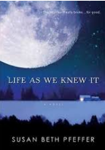  High school sophomore Miranda’s disbelief turns to fear in a split second when an asteroid knocks the moon closer to Earth, like "one marble hits another." The result is catastrophic. How can her family prepare for the future when worldwide tsunamis are wiping out the coasts, earthquakes are rocking the continents, and volcanic ash is blocking out the sun? | H2O  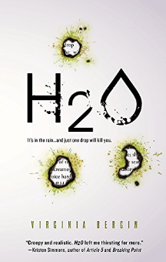  Ruby has survived the catastrophic onset of the killer rain. Two weeks after the radio started broadcasting the warning, "It's in the rain. It's fatal and there's no cure," the drinkable water is running out. Ruby's left with two options: persevere on her own, or embark on a treacherous journey across the country to find her father-if he's even still alive. | Not a Drop to Drink  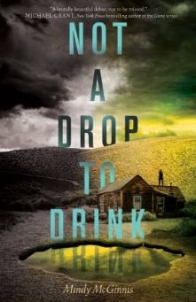  Teenage Lynn has been taught to defend her pond against every threat: drought, a snowless winter, coyotes, and most important, people looking for a drink. She makes sure anyone who comes near the pond leaves thirsty—or doesn't leave at all. | Ship Breaker  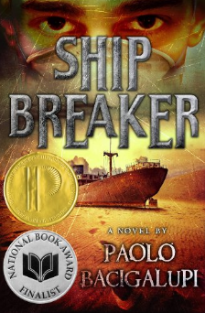  In America's Gulf Coast region, where grounded oil tankers are being broken down for parts, Nailer, a teenage boy, works the light crew, scavenging for copper wiring just to make quota--and hopefully live to see another day. But when, by luck or chance, he discovers an exquisite clipper ship beached during a recent hurricane, Nailer faces the most important decision of his life: Strip the ship for all it's worth or rescue its lone survivor | Flush (Class set available)  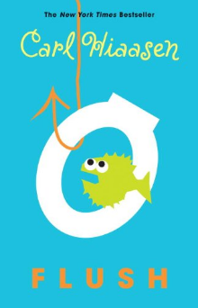  Noah's dad is sure that the owner of the Coral Queen casino boat is flushing raw sewage into the harbor—which has made taking a dip at the local beach like swimming in a toilet. He can't prove it though, and so he decides that sinking the boat will make an effective statement. Right. The boat is pumped out and back in business within days and Noah's dad is in the local lock-up. Now Noah is determined to succeed where his dad failed. He will prove that the Coral Queen is dumping illegally . . . somehow.
The Same Stuff as Stars (Class set available)  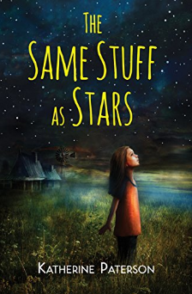  Grandma is aged and poor, and doesn’t make any attempt to care for the children—that’s left up to Angel, even though she is not yet twelve. The only bright spot in Angel’s existence is the Star Man, a mysterious stranger who appears on clear nights and teaches her all about the stars and planets and constellations. | DarkLife (Class set available)  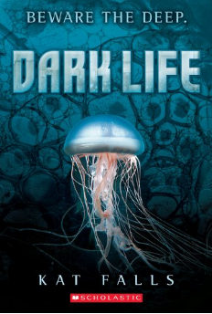  The oceans rose, swallowing the lowlands. Earthquakes shattered the continents, toppling entire regions into the rising water. Now, humans live packed into stack cities. The only ones with any space of their own are those who live on the ocean floor: the Dark Life | Journey to the Center of the Earth (Class set available)  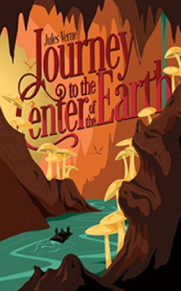  Professor Lidenbrock, his nephew, and a hired guide who, following the instructions of a medieval alchemist claiming to have found a passage to the center of the earth, travel deep into an Icelandic volcano. Deep in the earth, the dangers are beyond imaginable | Wrinkle in Time (Class set available)  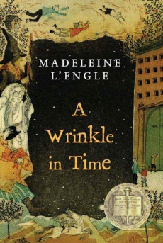  "Wild nights are my glory," the unearthly stranger told them. "I just got caught in a downdraft and blown off course. Let me sit down for a moment, and then I'll be on my way. Speaking of ways, by the way, there is such a thing as a tesseract." | Book of your choice  In order to choose a book of your choice, you must submit a proposal in order to justify that it relates to a standard that we have learned in class this year. You can see a complete list of the 6th grade science standards here: https://www.georgiastandards.org/standards/Georgia%20Performance%20Standards/SixthGradeRevisedStandards.pdf
Book 2:
Any other book from the Book 1 list | The Storm (must have read H20)  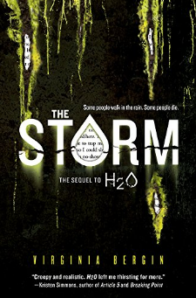  Ninety-seven percent of the population is dead. And the killer rain keeps falling. Ruby's not sure she can make it on her own much longer. Ruby gratefully accepts the army's protection. But safety comes with a price: If Ruby wants to stay, she must keep her eyes-and her mouth-shut | Rip Tide (must have read DarkLife)  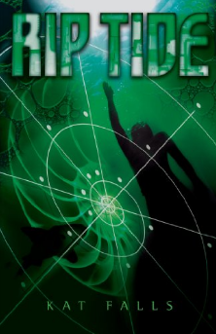  Ty has always known that the ocean is a dangerous place. Every time he swims beyond the borders of his family's subsea farm, he's prepared to face all manner of aquatic predators-sharks, squid, killer whales. What Ty isn't prepared to find in the deep is an entire township chained to a sunken submarine, its inhabitants condemned to an icy underwater grave | The Dead and the Gone (must have read Life as we Knew it) (Class set available)  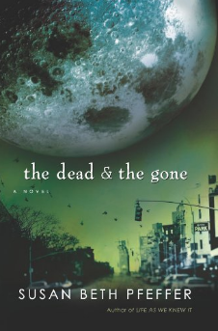  Now this harrowing companion novel examines the same events as they unfold in New York City, revealed through the eyes of seventeen-year-old Puerto Rican Alex Morales. When Alex's parents disappear in the aftermath of tidal waves, he must care for his two younger sisters, even as Manhattan becomes a deadly wasteland, and food and aid dwindle.

Final Report Grading:
Standard (10 pts): Pick a standard that best relates to the book your read. There can be more than one that relates. Explain how your book relates to that specific standard. https://www.georgiastandards.org/standards/Georgia%20Performance%20Standards/SixthGradeRevisedStandards.pdf
Facts (20 pts): List at least 10 facts from your book that are TRUE. Be sure to cite the page number that each fact was found on.
Fiction (10 pts): List at least 10 statements/situations that are not realistic. Explain why these situations could not happen or are not true. Be sure to cite the page number that each were found on.
Questions (10 pts): For at least 10 chapters, write down at least one question you have about what has happened. These need to be science related questions about what is happening in your book.
Answers (10 pts): After you have finished your book, go back and answer the questions you posed at the end of each chapter. You may need to research the answers using other resources.
Summary of the book (40 pts): Summarize what happened in your book (MAXIMUM 5 paragraphs). Within your summary, answer the following questions: Could your book actually happen? Why or why not? Would you have made any changes to your book based on what you have learned in class this year? Why or why not?
Name: _____________________________________________ Date: _________________ Period: ______________
The Ultra, Extreme, Intense but not too intense
Novel Study
Final Report Book #1
Title: ___________________________________________________ Author: __________________________
Standard (10 pts): Pick a standard that best relates to the book your read. There can be more than one that relates. Explain how your book relates to that specific standard.
__________________________________________________________________________________________
__________________________________________________________________________________________
__________________________________________________________________________________________
__________________________________________________________________________________________
__________________________________________________________________________________________
Questions (10 pts): For at least 10 chapters, write down at least one question you have about what has happened. These need to be science related questions about what is happening in your book. Answers (10 pts): After you have finished your book, go back and answer the questions you posed at the end of each chapter. You may need to research the answers using other resources.
Chapter ___________
Question #1: _____________________________________________________________________________
Answer: _________________________________________________________________________________
Chapter ___________
Question #2: _____________________________________________________________________________
Answer: _________________________________________________________________________________
Chapter ___________
Question #3: _____________________________________________________________________________
Answer: _________________________________________________________________________________
Chapter ___________
Question #4: _____________________________________________________________________________
Answer: _________________________________________________________________________________
Chapter ___________
Question #5: _____________________________________________________________________________
Answer: _________________________________________________________________________________
Chapter ___________
Question #6: _____________________________________________________________________________
Answer: _________________________________________________________________________________
Chapter ___________
Question #7: _____________________________________________________________________________
Answer: _________________________________________________________________________________
Chapter ___________
Question #8: _____________________________________________________________________________
Answer: _________________________________________________________________________________
Chapter ___________
Question #9: _____________________________________________________________________________
Answer: _________________________________________________________________________________
Chapter ___________
Question #10: ____________________________________________________________________________
Answer: _________________________________________________________________________________

Facts (20 pts): List at least 10 facts from your book that are TRUE. Be sure to cite the page number that each fact was found on.
Fact 1: page number ______
__________________________________________________________________________________________
__________________________________________________________________________________________
Fact 2: page number _____
__________________________________________________________________________________________
__________________________________________________________________________________________
Fact 3: page number _____
__________________________________________________________________________________________
__________________________________________________________________________________________
Fact 4: page number _____
__________________________________________________________________________________________
__________________________________________________________________________________________
Fact 5: page number _____
__________________________________________________________________________________________
__________________________________________________________________________________________
Fact 6: page number _____
__________________________________________________________________________________________
__________________________________________________________________________________________
Fact 7: page number _____
__________________________________________________________________________________________
__________________________________________________________________________________________
Fact 8: page number _____
__________________________________________________________________________________________
__________________________________________________________________________________________
Fact 9: page number _____
__________________________________________________________________________________________
__________________________________________________________________________________________
Fact 10: page number _____
__________________________________________________________________________________________
__________________________________________________________________________________________

Fiction (10 pts): List at least 10 statements/situations that are not realistic. Explain why these situations could not happen or are not true. Be sure to cite the page number that each were found on.
Fiction 1: page number _____
__________________________________________________________________________________________
__________________________________________________________________________________________
Fiction 2: page number _____
__________________________________________________________________________________________
__________________________________________________________________________________________
Fiction 3: page number _____
__________________________________________________________________________________________
__________________________________________________________________________________________
Fiction 4: page number _____
__________________________________________________________________________________________
__________________________________________________________________________________________
Fiction 5: page number _____
__________________________________________________________________________________________
__________________________________________________________________________________________
Fiction 6: page number _____
__________________________________________________________________________________________
__________________________________________________________________________________________
Fiction 7: page number _____
__________________________________________________________________________________________
__________________________________________________________________________________________
Fiction 8: page number _____
__________________________________________________________________________________________
__________________________________________________________________________________________
Fiction 9: page number _____
__________________________________________________________________________________________
__________________________________________________________________________________________
Fiction 10: page number _____
__________________________________________________________________________________________
__________________________________________________________________________________________
Summary of the book (40 pts): Summarize what happened in your book (MAXIMUM 5 paragraphs). Within your summary, answer the following questions: Could your book actually happen? Why or why not? Would you have made any changes to your book based on what you have learned in class this year? Why or why not? (You may type this or write it on another sheet of paper).

Name: _____________________________________________ Date: _________________ Period: ______________
The Ultra, Extreme, Intense but not too intense
Novel Study
Final Report Book #2
Title: ___________________________________________________ Author: __________________________
Standard (10 pts): Pick a standard that best relates to the book your read. There can be more than one that relates. Explain how your book relates to that specific standard.
__________________________________________________________________________________________
__________________________________________________________________________________________
__________________________________________________________________________________________
__________________________________________________________________________________________
__________________________________________________________________________________________
Questions (10 pts): For at least 10 chapters, write down at least one question you have about what has happened. These need to be science related questions about what is happening in your book. Answers (10 pts): After you have finished your book, go back and answer the questions you posed at the end of each chapter. You may need to research the answers using other resources.
Chapter ___________
Question #1: _____________________________________________________________________________
Answer: _________________________________________________________________________________
Chapter ___________
Question #2: _____________________________________________________________________________
Answer: _________________________________________________________________________________
Chapter ___________
Question #3: _____________________________________________________________________________
Answer: _________________________________________________________________________________
Chapter ___________
Question #4: _____________________________________________________________________________
Answer: _________________________________________________________________________________
Chapter ___________
Question #5: _____________________________________________________________________________
Answer: _________________________________________________________________________________
Chapter ___________
Question #6: _____________________________________________________________________________
Answer: _________________________________________________________________________________
Chapter ___________
Question #7: _____________________________________________________________________________
Answer: _________________________________________________________________________________
Chapter ___________
Question #8: _____________________________________________________________________________
Answer: _________________________________________________________________________________
Chapter ___________
Question #9: _____________________________________________________________________________
Answer: _________________________________________________________________________________
Chapter ___________
Question #10: ____________________________________________________________________________
Answer: _________________________________________________________________________________

Facts (20 pts): List at least 10 facts from your book that are TRUE. Be sure to cite the page number that each fact was found on.
Fact 1: page number ______
__________________________________________________________________________________________
__________________________________________________________________________________________
Fact 2: page number _____
__________________________________________________________________________________________
__________________________________________________________________________________________
Fact 3: page number _____
__________________________________________________________________________________________
__________________________________________________________________________________________
Fact 4: page number _____
__________________________________________________________________________________________
__________________________________________________________________________________________
Fact 5: page number _____
__________________________________________________________________________________________
__________________________________________________________________________________________
Fact 6: page number _____
__________________________________________________________________________________________
__________________________________________________________________________________________
Fact 7: page number _____
__________________________________________________________________________________________
__________________________________________________________________________________________
Fact 8: page number _____
__________________________________________________________________________________________
__________________________________________________________________________________________
Fact 9: page number _____
__________________________________________________________________________________________
__________________________________________________________________________________________
Fact 10: page number _____
__________________________________________________________________________________________
__________________________________________________________________________________________

Fiction (10 pts): List at least 10 statements/situations that are not realistic. Explain why these situations could not happen or are not true. Be sure to cite the page number that each were found on.
Fiction 1: page number _____
__________________________________________________________________________________________
__________________________________________________________________________________________
Fiction 2: page number _____
__________________________________________________________________________________________
__________________________________________________________________________________________
Fiction 3: page number _____
__________________________________________________________________________________________
__________________________________________________________________________________________
Fiction 4: page number _____
__________________________________________________________________________________________
__________________________________________________________________________________________
Fiction 5: page number _____
__________________________________________________________________________________________
__________________________________________________________________________________________
Fiction 6: page number _____
__________________________________________________________________________________________
__________________________________________________________________________________________
Fiction 7: page number _____
__________________________________________________________________________________________
__________________________________________________________________________________________
Fiction 8: page number _____
__________________________________________________________________________________________
__________________________________________________________________________________________
Fiction 9: page number _____
__________________________________________________________________________________________
__________________________________________________________________________________________
Fiction 10: page number _____
__________________________________________________________________________________________
__________________________________________________________________________________________
Summary of the book (40 pts): Summarize what happened in your book (MAXIMUM 5 paragraphs). Within your summary, answer the following questions: Could your book actually happen? Why or why not? Would you have made any changes to your book based on what you have learned in class this year? Why or why not? (You may type this or write it on another sheet of paper).

