Polynesian Seafarers

Masters of Ocean Currents
https://divediscover.whoi.edu/history-of-oceanography/polynesian-seafarers/
About 30,000 years ago, human cultures along the western coastline of the Pacific Ocean—in the area between what is now Australia and China—started to migrate eastward across the great expanse of the Pacific Ocean. We are not sure exactly why the migrations started, but tribal wars, disease epidemics, the search for food, or natural disasters such as large volcanic eruptions and earthquakes, may have been factors.
Over about 25,000 years, these people, called the Polynesians, eventually colonized the islands of the south and western Pacific, from New Guinea in the west to Fiji and Samoa in the middle. Then they moved onward to Tahiti and finally Easter Island in the eastern south Pacific. The Polynesians colonized the Hawaiian Islands about 500 years ago. The Hawaiian Islands are among the world’s most remote island groups and were one of the last major island groups to be colonized by native cultures. How did the Polynesians manage to travel across thousands of miles of ocean without compasses, sextants, clocks, or other tools of modern navigation? Their migration was truly one of the great achievements of early seafaring cultures, and it marks the start of oceanographic observations by people who lived in harmony with the ocean.
The Polynesians were very observant. They noted the directions that waves came from and how they affected or rocked their canoes. They had a keen sense of ocean currents and variations in bird and sea life in different places in the Pacific. They also were among the first people to use astronomical observations of the stars to help them navigate across the ocean.
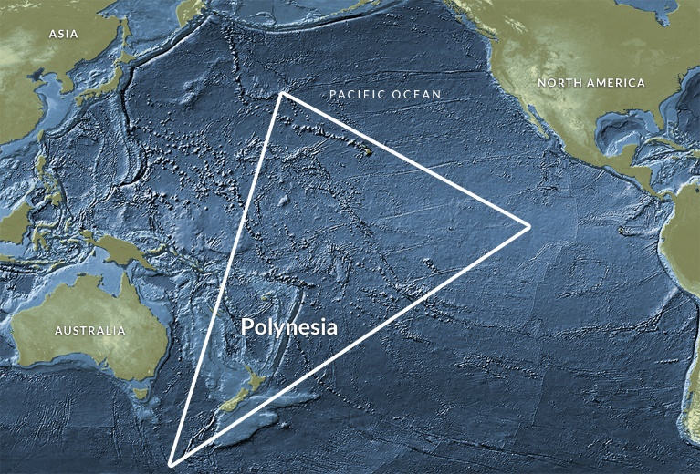
They made the earliest form of navigational or oceanographic map, called stick charts. These were made of pieces of bamboo or other wood that were tied together. The locations of islands were often marked with shells or knots, and curved pieces of wood represented the bending of ocean waves around the islands and the way waves rocked their canoes. Polynesians handed down their lore of the sea in both the oral and stick map traditions.

The Polynesian settlement of the Pacific formed a triangle which covered an area almost twice the size of the continental United States.

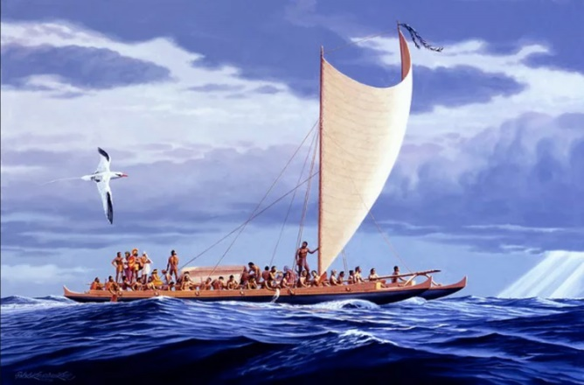
Painting of Hokule’a, a traditional Polynesian canoe by artist Greg Taylor of the Honolulu Advertiser (with permission).

Ocean Study And Exploration

https://www.britannica.com/place/Atlantic-Ocean/Study-and-exploration

Ancient exploration
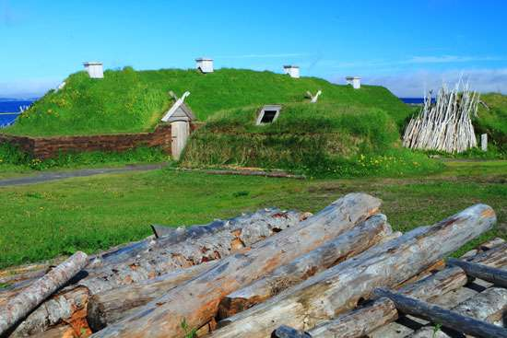
Advances in archaeological study have strengthened claims by many scholars that various seafaring peoples of the Mediterranean ventured into the open Atlantic before 600 BC and engaged in some transatlantic voyages perhaps as early as AD 545. Nevertheless, substantial debate continues over the extent and scope of pre-Viking explorations of the Atlantic. Widely accepted are the seafaring contributions of the Egyptians, Celts, Phoenicians, and Romans, whose trading and fishing forays led them certainly to the coastlines of western Africa and Greenland and possibly as far as the Caribbean and the Gulf of Mexico. The combined influence of gradual climatic change and the ravages of war led Viking and Norse sailors westward across the Atlantic beginning sometime around AD800 to 900. After numerous landings were made in Iceland during the 9th century, Greenland was explored in 982 and settled some three years later by Erik the Red. Similar expeditions brought Norse ships to the coasts of present-day Newfoundland and Labrador, as well as to that of Maine.

European voyages and settlement
The saga of discovery and settlement of the Americas and the Caribbean, begun by Europeans in the late 15th century, lasted more than 200 years. Successive transatlantic crossings—first into the Caribbean and then to the coast of Canada and along the coast of South America—describe the general pattern of exploration by the Spanish, Portuguese, Italians, French, and English. The clockwise circulation and current patterns that characterize the Atlantic were used to full advantage by seafarers, who would cross westward on steady prevailing northeasterly trades and use the Gulf Stream and westerly breezes of the North Atlantic for their return trips.
In 1492 the Italian Christopher Columbus crossed the Atlantic in a Spanish-backed attempt to find a new trading route to Asia. While that objective went unfulfilled, subsequent voyages by explorers such as John Cabot, Ferdinand Magellan, and Giovanni da Verrazzano did much to reveal both the complexities of transatlantic navigation and the nature of the Americas. By 1502 the rich fishery of the Grand Banks off Newfoundland was being exploited by English, French, and Portuguese ships. Crude attempts at depicting the coastline of North America from present-day Virginia northward to the Davis Strait had already begun by then. Simultaneously, Portuguese seafarers led by Bartolomeu Dias had pushed southward to the Cape of Good Hope, mapping the entire western coast of Africa in the process and proving the existence of a sea route between Europe and India. In 1520 Magellan discovered the strait, now bearing his name, that links the Atlantic and Pacific oceans. The discovery of Cape Horn at the southernmost tip of South America was made in 1578 by the English navigator Francis Drake; this provided a more suitable route for trading ships. Exploration provided the impetus for colonization, and, as isolated outposts gave way to larger protected settlements and military garrisons in the 17th and 18th centuries, exploitation of natural resources from both land and sea increased, as did the flow of colonists to the Americas and the Caribbean.
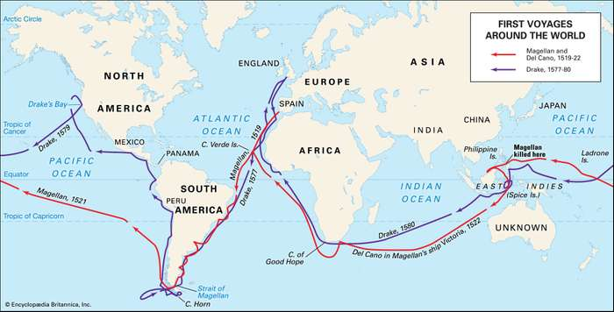
Voyages of Ferdinand Magellan (1519–22) and Francis Drake (1577–80) across the Atlantic Ocean and around the globe. Encyclopædia Britannica, Inc.

Early oceanography
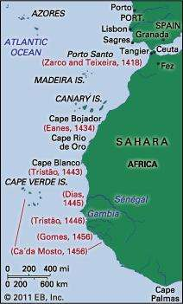
The groundwork for much of this exploration, as well as for early ocean science, can be attributed to Henry the Navigator, the 15th-century Portuguese prince whose school of oceanography at Sagres, Port., provided training for hundreds of seamen and advanced substantially the fields of ship design, simulation, and instrumentation. Modern efforts to study systematically the physical and biological properties of the Atlantic began in earnest during the 1800s and were notable for several pioneering research expeditions, the results of which form the basis for present-day scientific understanding of the oceans. While crude sampling and inaccurate measurement techniques led to numerous misconceptions during this time, the period also marked the advent of large-scale, multiyear scientific expeditions.

Incremental advances in both oceanographic theory and technique evolved from these early interdisciplinary studies of Atlantic processes. As early as 1770, the American Benjamin Franklin published the first good map of the Gulf Stream, based on data collected by Timothy Folger from the logs of transatlantic mail ships. The work of the American naval officer Matthew Fontaine Maury in the 1840s and ’50s paved the way for generations of future researchers. His exhaustive calculations of Atlantic winds and currents, as well as his early seafloor maps, were the beginning of modern oceanography in the United States.
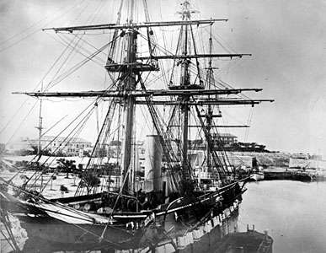
The advent of the telegraph and the dream of a transatlantic cable required improved knowledge of bathymetry (measurement of ocean depth), currents, topography, and bottom sediments. British and American naval ships were instrumental in conducting hydrographic surveys in support of the early attempts to lay a transatlantic cable; the first successful cable was laid in 1866. A watershed expedition made by HMS Challenger in 1872–76 generated thousands of observations in the Atlantic and other ocean basins, culminating in the publication of 50 volumes of data on currents, water depth, temperature, ocean sediments, and animal and plant species. Other important contributions of the late 19th and early 20th centuries include those of Albert I of Monaco and of many Scandinavians, including Bjørn Helland-Hansen and V. Walfrid Ekman. Prince Albert financed a fleet of oceanographic vessels whose efforts led to improved understanding of North Atlantic currents and to the discovery of many new species of mid-depth fishes.
HMS Challenger docked in Bermuda, 1865.Hulton Archive/Getty Images
The disaster in 1912 of the Titanic catalyzed research efforts concerned with iceberg flows and current patterns in the North Atlantic, accelerated the development of both radio and sonar, and led to the establishment of the International Ice Patrol. In the field of marine communications, the Italian Guglielmo Marconi was demonstrating his new invention—wireless radio—in Europe and the United States during this period, having used it in 1899 to report from sea the results of the America’s Cup yacht races. In 1925–27 a series of scientific voyages by the research vessel Meteor established Germany as a leader in marine research. Operating in the waters of the South Atlantic, the Meteor traversed the basin 14 times, mapping the seafloor by means of sonar and measuring salinity and temperature distributions at various depths.

