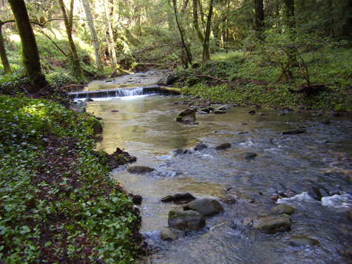

**Is your student struggling with a concept?**

Science Tutoring is available Tuesday Mornings at 8:15

Units that your student will be learning:

1. Rocks, Minerals, Safety
2. Weathering, Erosion and Soil
3. Dynamic Earth
4. Water on Earth
5. Climate and Weather
6. Earth, Moon, and Sun
7. Solar System and Universe

Ins and Outs:

Your student will have 7 Science Folders throughout the year (one for each unit) during the school year.

THIS IS A FLIPPED CLASSROOM

EXPECT HOMEWORK EVERY NIGHT (check the blog)

e-mail: Brittany.dudek@cobbk12.org

Phone: (770)-578-2740 ext. 404

Blog: <http://msdudekswebsite.weebly.com/>

## Open House Night:

Ms. Brittany Dudek

Your Student’s 6th Grade Earth Science

Fall 2015

***byline*[Name]**

Integer metus.

Lorem.