Name: ____________________________________________
Journey Through the rock Cycle
_____________________________________________________________________________________
_____________________________________________________________________________________
_____________________________________________________________________________________
_____________________________________________________________________________________
_____________________________________________________________________________________
_____________________________________________________________________________________
_____________________________________________________________________________________
_____________________________________________________________________________________
_____________________________________________________________________________________
_____________________________________________________________________________________
_____________________________________________________________________________________
_____________________________________________________________________________________
_____________________________________________________________________________________
_____________________________________________________________________________________
_____________________________________________________________________________________
_____________________________________________________________________________________
_____________________________________________________________________________________
_____________________________________________________________________________________
_____________________________________________________________________________________
_____________________________________________________________________________________
_____________________________________________________________________________________
_____________________________________________________________________________________
_____________________________________________________________________________________
_____________________________________________________________________________________

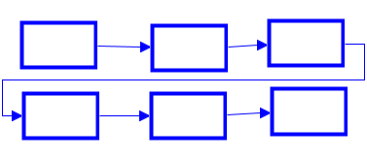
Plan your writing

Rubric
CATEGORY | OUT OF | ACHEIVED
Introduction | 10
Rock Cycle Referenced and explained how the pebble went through the steps | 40
Conclusion | 15
Creativity | 15
Makes sense/correct | 20

TOTAL: ______________
GRADE: ______________

