Unit 4 Test: Chapter 7 Plate Tectonics Review Sheet

S6E5.a Compare and contrast the Earth’s layers
S6E5.f Explain the effects of physical processes (plate tectonics) on geological features.

Part 1 (Layers of the Earth)
- List the 4 layers of Earth, beginning with the one we’re standing on:
Crust, mantle, outer core, inner core
- List the 3 main layers, and list what each is made of (elements):
Crust—mostly silicon and oxygen (very light-weight elements)
Mantle—a lot of magnesium
Core—iron and nickel (very dense metals)

Part 2 (Density and Temperature)
- Which layer is the thinnest? crust

- List Earth’s layers from least dense to most dense:
Crust, mantle, core

- Which layer is the hottest? Inner core

Part 3 (Crust)
- Ocean Crust Continental Crust
Thicker/Thinner thinner (about 5 km thick) thicker (up to 100 km thick)
Main Type of Rock basalt granite
Density denser (so sinks) less dense (so rises)
- Why does oceanic crust subduct under continental crust (if they collide)?
Because the ocean crust is made of basalt, which is denser than the granite (continental crust)

Part 4 (CORE)

- Outer Core Inner Core
Solid or liquid liquid solid (due to so much pressure)
Temperature hot (3,000-5,000 °C) hottest (5,000-7,000 °C)
More/less pressure less pressure most pressure
More/less dense less dense most dense
Composition (elements) iron and nickel iron and nickel

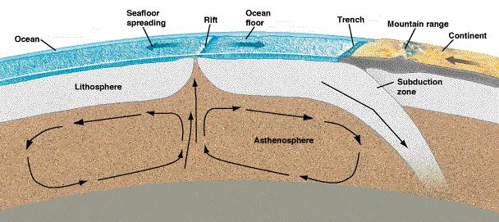
Part 5 (Lithospheric plates)
- Sketch the lithosphere and asthenosphere. Which one is completely solid? lithosphere is all solid

- What makes the lithospheric (tectonic) plates move? (Wegener did not know about these)—convection currents in the asthenosphere

- What lithospheric plate do we live on? North American Plate
Which lithospheric plate is Hawaii on? Pacific Plate

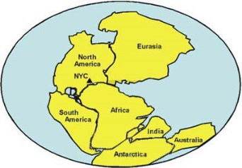
Part 6 (Continental Drift Theory)
- What is Pangaea? Alfred Wegener’s landmass that existed when all continents were joined, from about 300 to 200 million years ago (when the dinosaurs were around).

- What evidence did Wegener have that Pangaea existed and the continents started drifting apart millions of years ago? (1) South America and Africa seem to fit together
(2) rocks and mountains of the same age and type line up when the continents put back together
(3) plant and animal fossil evidence
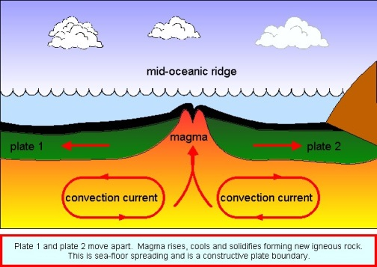

Part 7 (Mid-Ocean Ridges)
14. Sketch the mid-ocean ridge (include the plate movements). Is it a convergent, divergent, or transform boundary?

15. What is the name of the mid-ocean ridge in the Atlantic Ocean?
Mid-Atlantic Ridge
16. Where has it built up so high that it has created a volcanic island?
Iceland

Part 8 (Boundaries)
16. Which way do plate boundaries move?

>transform boundaries >convergent boundaries >divergent boundaries
--slide sideways past each other ---come together (collide) --come apart

17. Why do tsunamis form? STRONG earthquakes (or volcanoes) underwater

18. Why does California have so many earthquakes? What type of plate boundary is here (at the San Andres Fault)?
California is on two different plates (one moves north and one moves south)—a transform boundary
19. Specifically, what type of plate boundary formed the Himalayan Mountains (folded mountains)?
Convergent boundary (Indian Plate ran into the Eurasian Plate)
20. Why do rift valleys form (like the Red Sea or the Great Rift Valley in Africa)?
Divergent boundary (two continental/land plates moving apart)

