The OCEAN FLOOR is not all smooth or level. It has features similar to the land surface of the Earth.

______________ used to find how deep the ocean is:
Depth = Velocity x time
(where V=1,500 m/s
and only use half time)

Sample PROBLEM:
Pings from a sonar aboard a ship makes a round trip in 8 seconds. How far beneath the ship is the ocean floor? (remember that you only want HALF of the time)

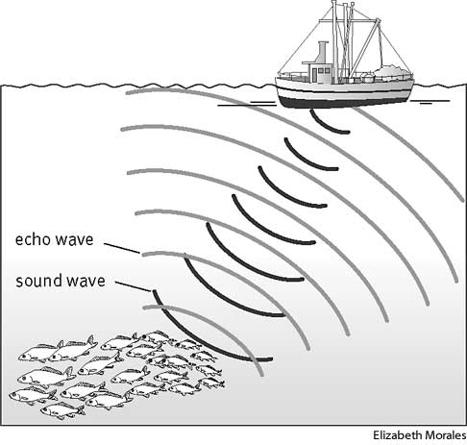

Water pressure __________ the deeper you go.
THE CONTINENTAL MARGIN
1 – continental __________--flat area next to the beach
2 – continental __________--steep area
3 – continental rise

Make a sketch:

WHAT MAKES UP THE OCEAN FLOOR?
- Abyssal ________=flat area of ocean floor
- Mid-Ocean Ridge= ____________ boundary
- _______________= underwater volcano (called a _____________ if it reaches the surface)
- Trench= _____________ boundary (ocean to ocean OR continent to ocean)

