CURRENTS
1. A _______________ is a large stream of moving water that flows through oceans.
UNLIKE waves, currents carry water great distances (waves only transport energy).

2 TYPES OF CURRENTS
2. ______________ currents caused by global winds (deflected by and Earth spinning/Coriolis)
3. __________ currents (caused by density differences)
SURFACE CURRENTS —2 to know (label below on map)
4.The _________Stream
- located in the ____________ Ocean
- caused by strong winds from the __________ (hint: it’s a WARM current)
- largest surface current in the world

5. The____________ Current
- COLD current in ____________ Ocean
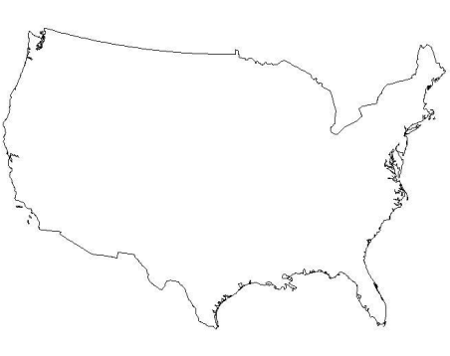

SURFACE CURRENTS AND CLIMATE
6.____________ is the average temperature and precipitation of an area over a long period of time.
*Give an example of an ocean current affecting the climate of an area?*

DEEP CURRENTS
7. Deep currents are caused by _________ differences (remember that surface currents are caused by global winds)

Density= mass
volume
y= mass
volume

The density of water depends on its
8 – ___________________ (__________ water sinks, and warm water rises)
9 – _________________ (saltier water __________)
WAVES
Waves are mainly caused by 10._________ (sometimes underwater earthquakes or landslides)
Wave size depends on:
11—wind __________
12—how long the wind blows
13—the _________ over which the wind blows

14. PARTS OF A WAVE
Label the parts using the diagram at your station.
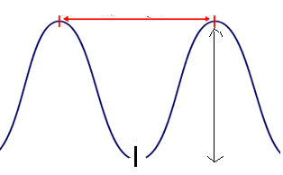

15. Wave energy moves _________, but the water molecules just move in 16. a small ___________.

17. _______________ --giant wave caused by powerful underwater 18. ____________

Where do most Tsunamis occur??
_______________________

TIDES
19. Tides are the daily rise and fall of Earth’s waters on its coastlines because of the gravitational pull of 20. the _________ (the sun’s gravity only plays a small part in tides because it’s so far away).

When the water reaches its highest point (twice a day), it is called ________ tide (points B & D on diagram below).
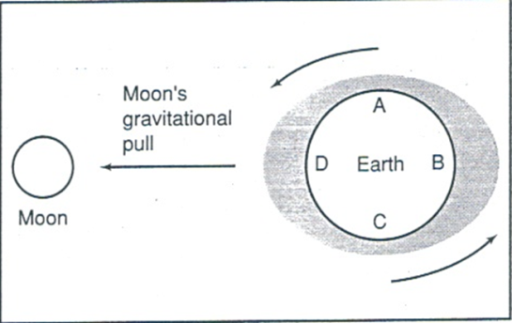

21. When the water is lowest on the beach (twice a day), it is called _________ tide (points A & C on diagram above).

On the back, make a double bubble to compare and contrast the two types of extreme tides:
- Spring tide (figures 1 & 2)
- Neap tide (figures 3 & 4)

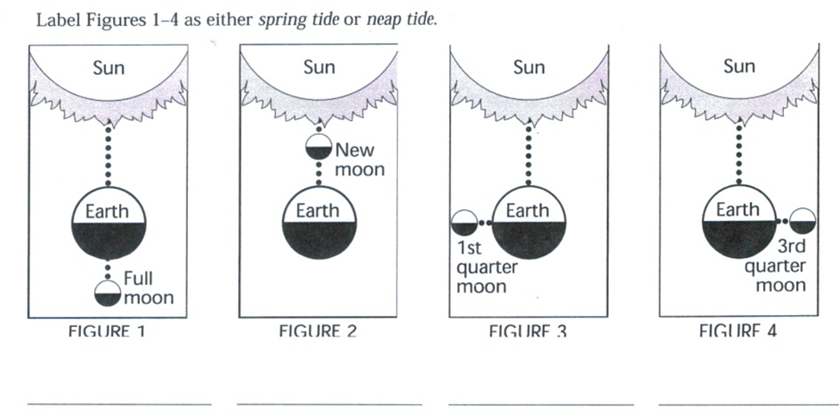
In the space below, create a double bubble map comparing and contrasting the spring tide and the neap tide.

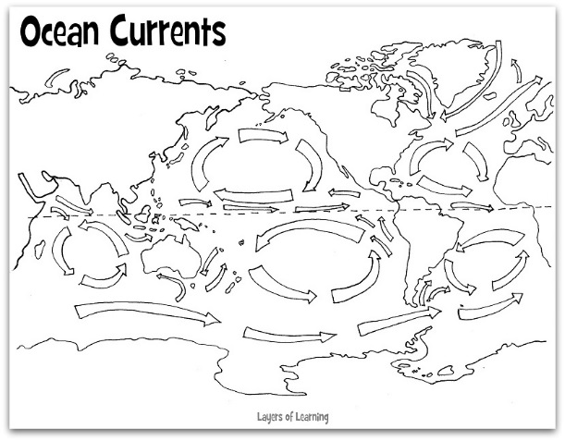
Australia
Africa
Greenland
Antarctica
South America
North America
Europe
Asia

