Name: _______________________________________ Date: ________________ Period: _________________
Rock Cycle and Soil Quiz
Part 1:
1-3. What happens during the rock cycle?---fill in the following BRIDGE map:

Weathering ? Deposition
? Moves sediment ?

Part 2:

1. Sediment is formed when rock gets ________________
a. younger
b. weathered
c. deposited
d. compacted

2. Which of the following is an example of sediment?
a. clay
b. gravel
c. sand
d. pieces of shells
e. all of the above are examples of sediment

Part 3:
In the following tree map, fill in the following weathering words:
chemical, abrasion, rusting, ice wedging, acid rain

Weathering

Mechanical _______________

root pry oxidation

___________ __________

___________ __________

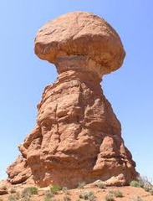
Part 4:
- What type of weathering is shown in the picture to the right?
(this picture was taken in the desert)
  - Abrasion
  - Ice Wedging
  - Acid Rain
  - Root Pry
  - Gophers and Rabbits
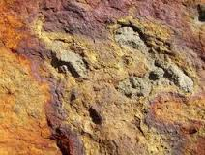
- What type of weathering is shown in the picture to the right? (hint: the orange color is important)
  - Abrasion
  - Ice Wedging
  - Rusting/oxidation
  - Gravity
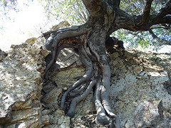
  - Root Pry
- What type of weathering is shown in the picture to the right? (hint: notice the leaves on the tree)
  - Abrasion
  - Ice Wedging
  - Rusting/oxidation
  - Gravity
  - Root Pry

- Both pictures below are both showing ____________ weathering.
  - mechanical
  - chemical
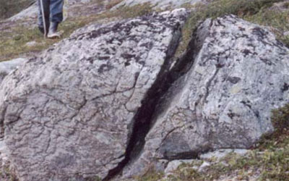
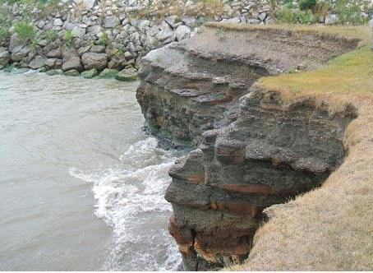

Part 5:
1-2. Fill in the brace map about what makes up soil:

____________________

Soil Composition _____________________

______Air and water____

3. Briefly, how does soil form? (which process?)
a. erosion b. deposition c. weathering

Part 6:
1. Considering that it takes thousands of year to make new soil, is soil a renewable or nonrenewable natural resource?

Matching (soil conservation):
Choices:
- Wind break
- Crop rotation
- Terracing
- Contour plowing
- No-till farming

_____ 2. planting different crops each year
(ex: corn one year, beans the next)
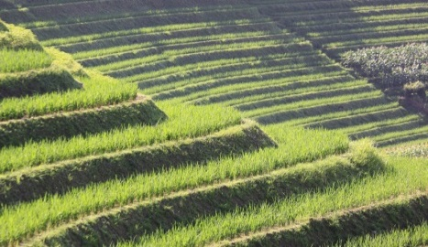
_____ 3. making steps on the
side of a mountain
to slow down water
erosion

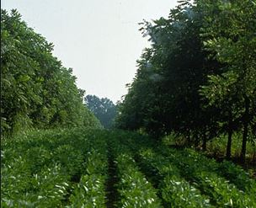
_____ 4. plant trees/bushes
to slow down wind erosion

>> Bonus: What was the main cause of the Dust Bowl of the 1930’s?
a. lightning b. insects c. drought d. energy shortage

Part 7:
1. What is the name of the layer of soil just under the grass? (hint: also called the “A-horizon” and has a lot of humus)?
a. subsoil
b. bedrock
c. topsoil
2. (true or false) The sediments in topsoil is MORE weathered than the sediments in subsoil.
a. true b. false
3. Why is topsoil so important to farming and gardening?
a. it contains a lot of organic material, which contains nutrients
(food) for the plants
b. it contains large pieces of gravel that helps hold plants in the
ground
c. topsoil is tasty in cereal bars
d. topsoil is not important to farmers and gardeners
4. After digging deeper and deeper, you would eventually hit solid (unweathered) rock, called _______________.

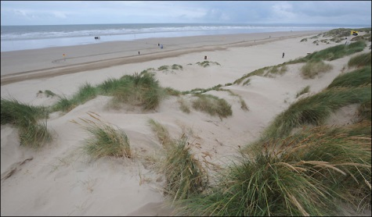
Part 8:

1. Question: What force creates and moves these sand dunes?

Answers: waves and ____________

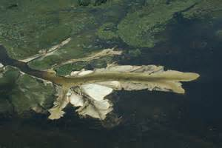
2. A delta at the end of a river is formed by
a. chemical weathering
b. deposition
c. mechanical weathering
d. landslide

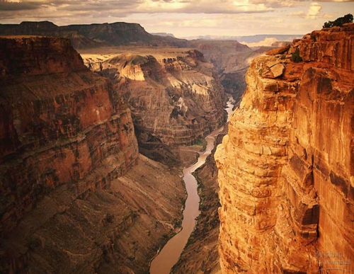
3. How did this canyon in Arizona formed. (Which process?)
a. river erosion
b. deposition
c. ice wedging
d. root pry

