LOCAL WINDS: Sea Breezes and Land Breezes
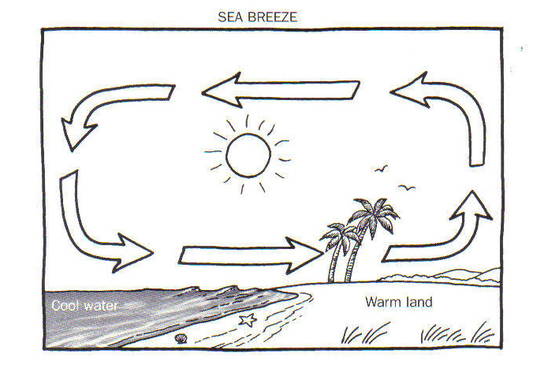

1) Sea Breeze:
During the day, the air over the ocean is colder, denser, and higher pressure. It flows to the lower pressure air over the land. Warmer, less dense air over the land rises and flows to the ocean.

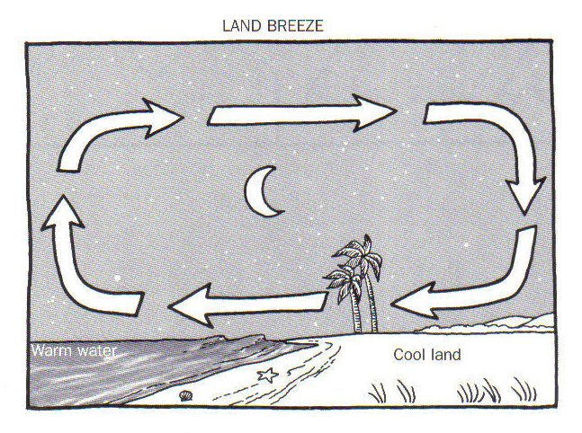

2) Land Breeze:
At night, the air over the land is colder and higher pressure, because the sun has gone down. The air moves toward the ocean because the air over the ocean is now warmer and lower pressure. The air over the ocean rises and travels towards the land.
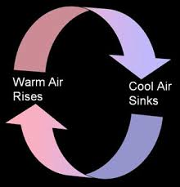
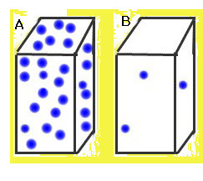

3) Both Sea Breezes and Land Breezes are both examples of convection currents!
Convection currents are the rising and sinking of warm and cold air or liquid. Colder air is more dense and higher pressure air sinks. Figure A shows very dense cold air molecules. Warmer air and liquid is less dense and lower pressure. Figure B shows less dense warm air molecules. Convection explains that warmer, lower pressure, less dense air rises. Colder, higher pressure, more dense air sinks. This creates the circulation of warm and cold air, called convection!

Pressure Gradient Force:
- The difference in air pressure between the land and the water is called a pressure gradient.
- The pressure gradient provides the force that makes the wind blow.
- The speed of the wind depends on the pressure gradient.

- Use the information and diagrams to answer the following questions about Sea Breezes.
  - During the day when the sun is shining, is the land hotter or colder? __________________________
  - During the day when the sun is shining, is the water hotter or colder? __________________________
  - During the day, does warm air rise from the ocean or from the land? ____________________________
- During the day, when the water is colder and the land is warmer, explain the pattern of air circulation.
_________________________________________________________________________________________________________________________
- Use the information and diagrams to answer the following questions about Land Breezes.
  - At night, when the sun has gone down, is the land hotter or colder? ______________________________
  - At night, when the sun has gone down, is the water hotter or colder? ____________________________
  - At night, does warm air rise from the ocean or from the land? _____________________________
- At night, when the water is warmer and the land is colder, explain the pattern of air circulation.
_________________________________________________________________________________________________________________________
- Read carefully what it says about air temperature, pressure and density!
  - Is colder air higher or lower pressure? _________________ Less dense or more dense? ______________
  - Is warmer air higher or lower pressure? _________________ Less dense or more dense? _____________
11. Circle True or False:
- (True or False) Higher pressure air flows to fill lower pressure areas.
- (True or False) Lower pressure air flows to fill higher pressure areas.

- In 2 sentences, describe pressure gradient forces and how they create the wind.
_________________________________________________________________________________________________________________________
_________________________________________________________________________________________________________________________
13. In 2 sentences explain convection currents and how they create the wind.
_________________________________________________________________________________________________________________________
_________________________________________________________________________________________________________________________
14. Sketch a diagram of a land breeze and a sea breeze and explain what is happening in each.

Land Breeze Diagram: Sea Breeze Diagram:

Land Breeze Explanation: Sea Breeze Explanation:

