SEASONS
The Reason for the Seasons is _________________________________________________
Season | Biological Changes (plants AND animals) | Holidays, sports, school events | Meteorological changes | Beginning day’s name and date | SKETCH  (circle A, B, C or D)
Spring |  |  |  | Vernal Equinox (March 20th) | 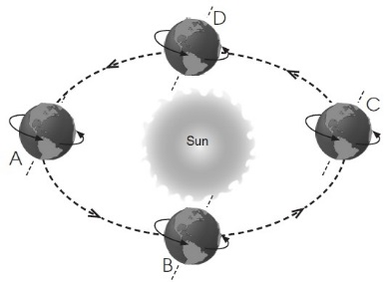
Summer |  | 4th of July, Labor day  Swimming  School begins
Autumn | Leaves change color and animals start to gather food to store
Winter |  |  | Colder temperatures  Snow, Sleet  Blizzards in the north

