**Silly Sally Error Analysis Name:_________________**

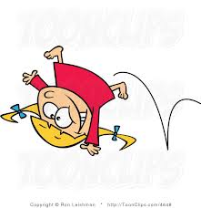

Sally is a silly little girl that makes silly mistakes! She also forgets to check her work when solving equations! ☹ **CHOOSE ANY 4 PROBLEMS BELOW**. Analyze her work in Column #1, and *circle her mistake*. In Column #2, explain what she did wrong. In Column #3, show how Silly Sally should work out the problem. Show ALL work (**include the “check”**)!

|  |  |  |
| --- | --- | --- |
| Silly Sally’s Work  (Circle her mistake): | What did Silly Sally do wrong? | Show Silly Sally how it’s done!  (Include the “check!” |
| x + 5 = 28  + 5 + 5  x = 33 |  |  |
| 12a = 108  12 12  a = 8 |  |  |
| w - 42 = 18  + 18 +18  w = 36 |  |  |
| = 3  ÷ 15 ÷ 15  y = 5 |  |  |
| x + 23.45 = 32  - 23.45 - 23.45  x = 9.45 |  |  |
| 4b = 60  4 4  b = 15 |  |  |

**\*\* Choose ONE Extension Problem, and complete it on the back of this sheet. \*\***

**Extension A**: Create a Bridge Map with 3 equations and their solutions.

**Extension B**: Write an equation for both of these situations AND solve:

a. Mrs. Ledesma went shopping and spent $45.62. She had $34.38 left over. How much did she start with?

b. A class of 32 students was given a homework assignment that had “x” number of problems to solve. The class had a total of 320 problems. Solve for “x”, the number of problems on the assignment.