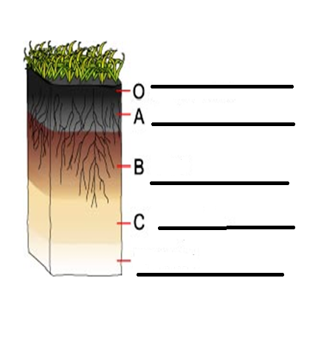
SOIL is a mixture of
♦_____________ rocks and minerals
♦___________ material (decayed plants/animals)-also called HUMUS
♦___________ and __________

>>Soil is NONrenewable because it takes ___________ of years to make
How is soil formed?
1. ____________________ of rocks and minerals
2. decomposing organic material (leaves, grass, animals, etc) called ____________
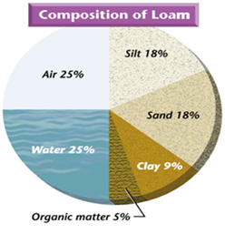
Why is soil so important?
- _____________--food for plants (which we eat).
- ________________--a place for animals to live
- ____________ storage—so plants can get the water they need (roots)
SOIL TEXTURE--What’s the difference between sand, silt, and clay?
….the _____________ of the particles (______ is the largest; __________ is the smallest)
(LOAM is a mix of all 3—best soil)

Basic Soil Horizons (LAYERS)
--also called the soil profile

