Name:______________________________

**SPRING BREAK MILESTONE REVIEW QUESTIONS**

**Unit 1 Review**

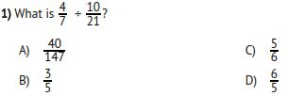

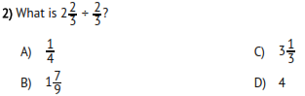

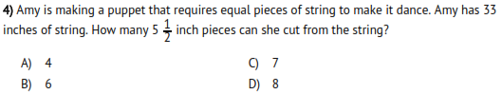

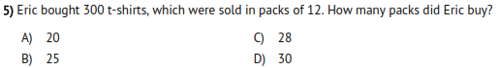

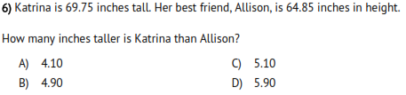

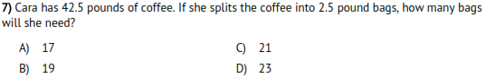

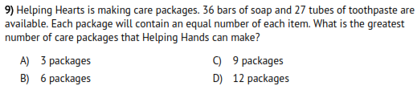

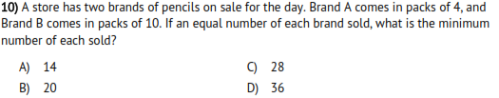

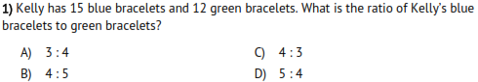

**Unit 2**

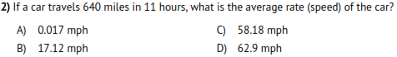

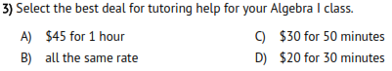

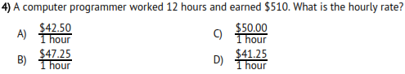

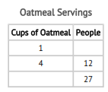

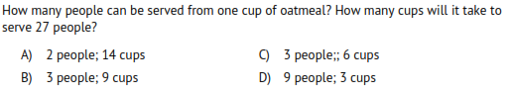

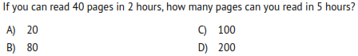

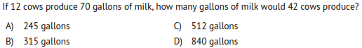

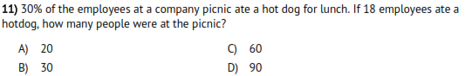

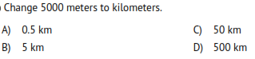

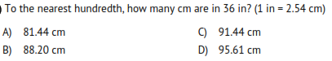

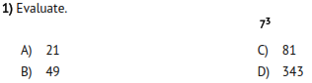

**Unit 3 & Unit 4**

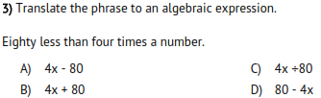

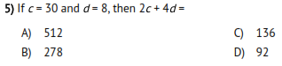

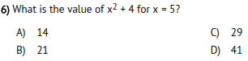

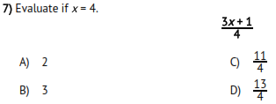

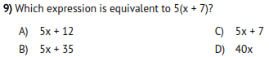

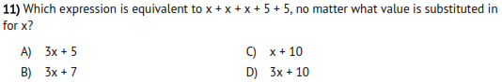

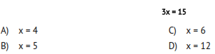

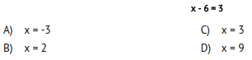

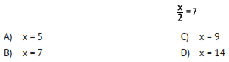

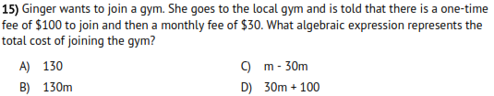

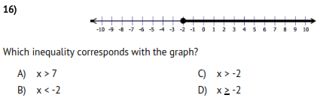

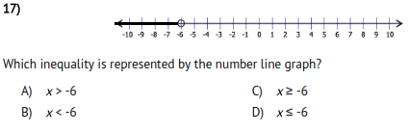

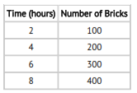

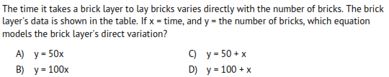

**Unit 6: Statistical Analysis Review**

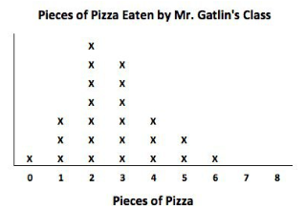

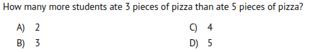

What is the range? ________

What is the mode? ________

How many students ate at least 4 pieces of pizza? _________

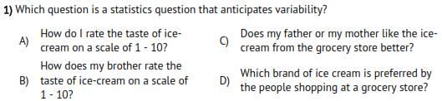

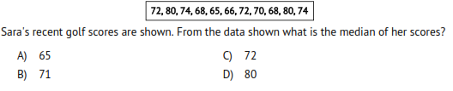

Using the data above, what is the range of her scores? ___________ Mode? ___________ Mean?___________

