Name: _____________________________________________ Date: _______________ Period: ___________
Unit 2 Remediation: Seasons, Moon, Tides
Part 1 – Seasons
- What causes a planet to have seasons?

- How long is Earth’s rotation?

- How long is Earth’s revolution?

- What is the date and name of the first day of each season?

Part 2—Moon Phases: Make a double bubble for each (or list three differences and three similarities)
- waxing and waning

- crescent and gibbous

- full and new moon

- quarter moons (1st and third/last)

PHASES OF THE MOON

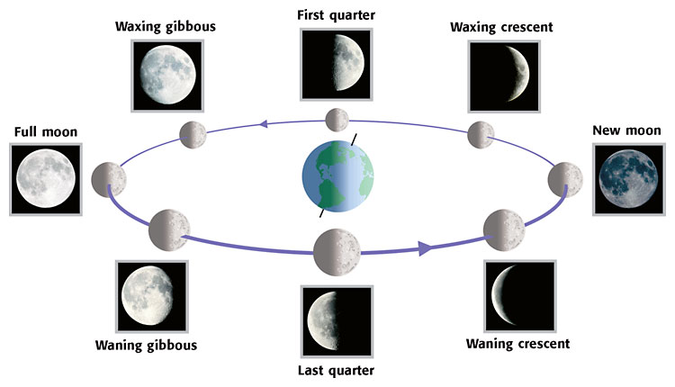
S
U
N

Part 3–Eclipses
- What type of eclipse is seen when a new moon moves in front of the sun (unsafe to look at directly)?

- What type of eclipse is seen when the Earth’s shadow moves in front of the full moon (safe to look at)?
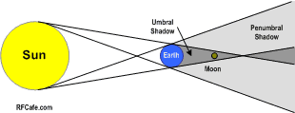

- Is this a solar or lunar eclipse? What phase of the moon would it be?

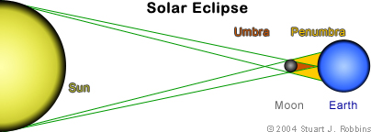

- Is this a solar or lunar eclipse? What phase of the moon would it be?

Part 4: Tides

- Why do we have tides? How many high tides do we have a day? How many low tides do we have a day?

- Draw the alignment of the sun, earth and moon needed for SPRING tide. (There should be two drawings)

- Draw the alignment of the sun, earth and moon needed for NEAP tide. (There should be two drawings)

- Make a double bubble comparing and contrasting SPRING and NEAP tide

