Unit 2 Vocabulary
Word | Definition | Picture/Example
Magma/Lava
Fossil
Composition
Texture
Rock Cycle
Weathering
Erosion
Igneous | When hot, liquid rock cools and solidifies
Metamorphic | Rocks that have been changed over a long period of time by pressure and heat
Sedimentary | Sedimentary rocks are formed by sediment that is deposited over time, usually as layers at the bottom of lakes and oceans.
Deposition
Compaction | Process where sediments are deeply buried, placing them under pressure because of the weight of other layers.
Cementation | Process where new minerals stick the grains together – just as cement (from a bag) binds sand grains together
Extrusive
Intrusive
Fine-Grained | You cannot see the mixture of minerals because the rock was cooled/formed quickly
Coarse-Grained | You CAN see the mixture of minerals because the rock was cooled/formed SLOWLY
Sediments | Examples can include: ____________________, ________________________, _________________, ______________________________.
Foliated vs. Nonfoliated
Heat and Pressure | This forms ______________________ types of rocks.
Granite and Basalt | These are both types of ___________________ rocks because ______________________________ __________________________________________
Paleontology
Clastic | This is a type of ________________________ rock and it is known for _________________________.
AC: Felsic
AC: Mafic
AC: Conglomerate
AC: Appalachian Plateau Region (GA)
AC: Valley & Ridge Region (GA)
AC: Blue Ridge Region (GA)
AC: Piedmont Region (GA)
AC: Coastal Plain Region (GA)
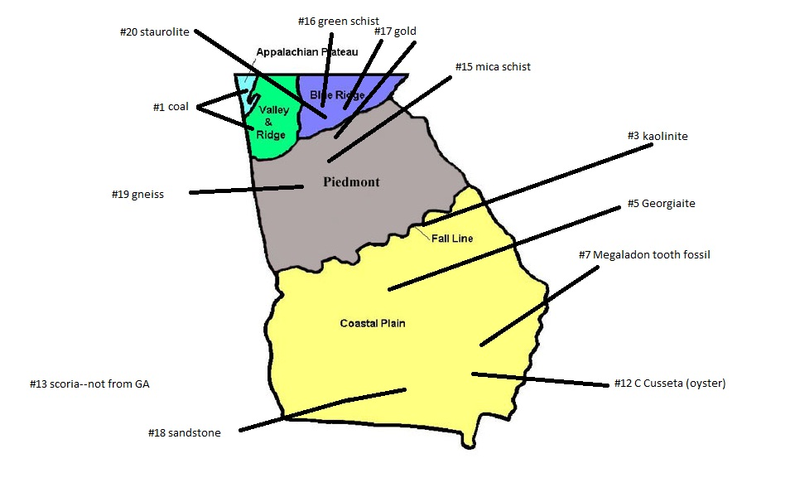
AC: Label the regions of
Georgia in the space below

