**Math 6** Name ___________________________________  
**Unit 4: Post Test REVIEW ☺** Date _______________

**Part I: Equations**

**Solve each equation**. Remember to show all work… perform the inverse operation to BOTH sides of the equation!

1.  2. 

**Part II: Inequalities**

3. You must be 12 or under to order from the kids’ menu.

Inequality: _____________________________

4. More than 400 kids made the Honor Roll for the first semester.

Inequality: _____________________________

5. Riders of the Scream Machine roller coaster must be at least 54 in. tall.

Inequality: _____________________________

1. What inequality is graphed on the number line?

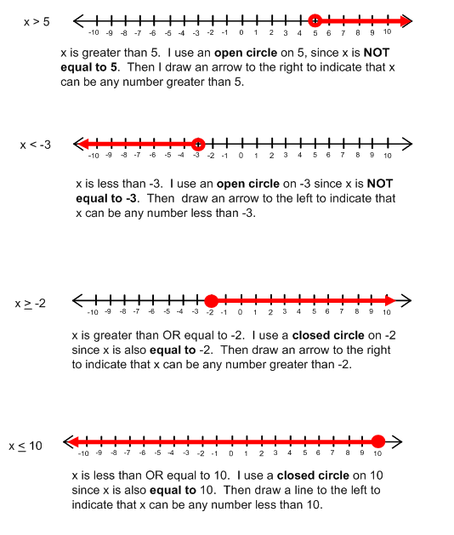

A. m < 5 B. m > 5 C. m < 5 D. m > 5

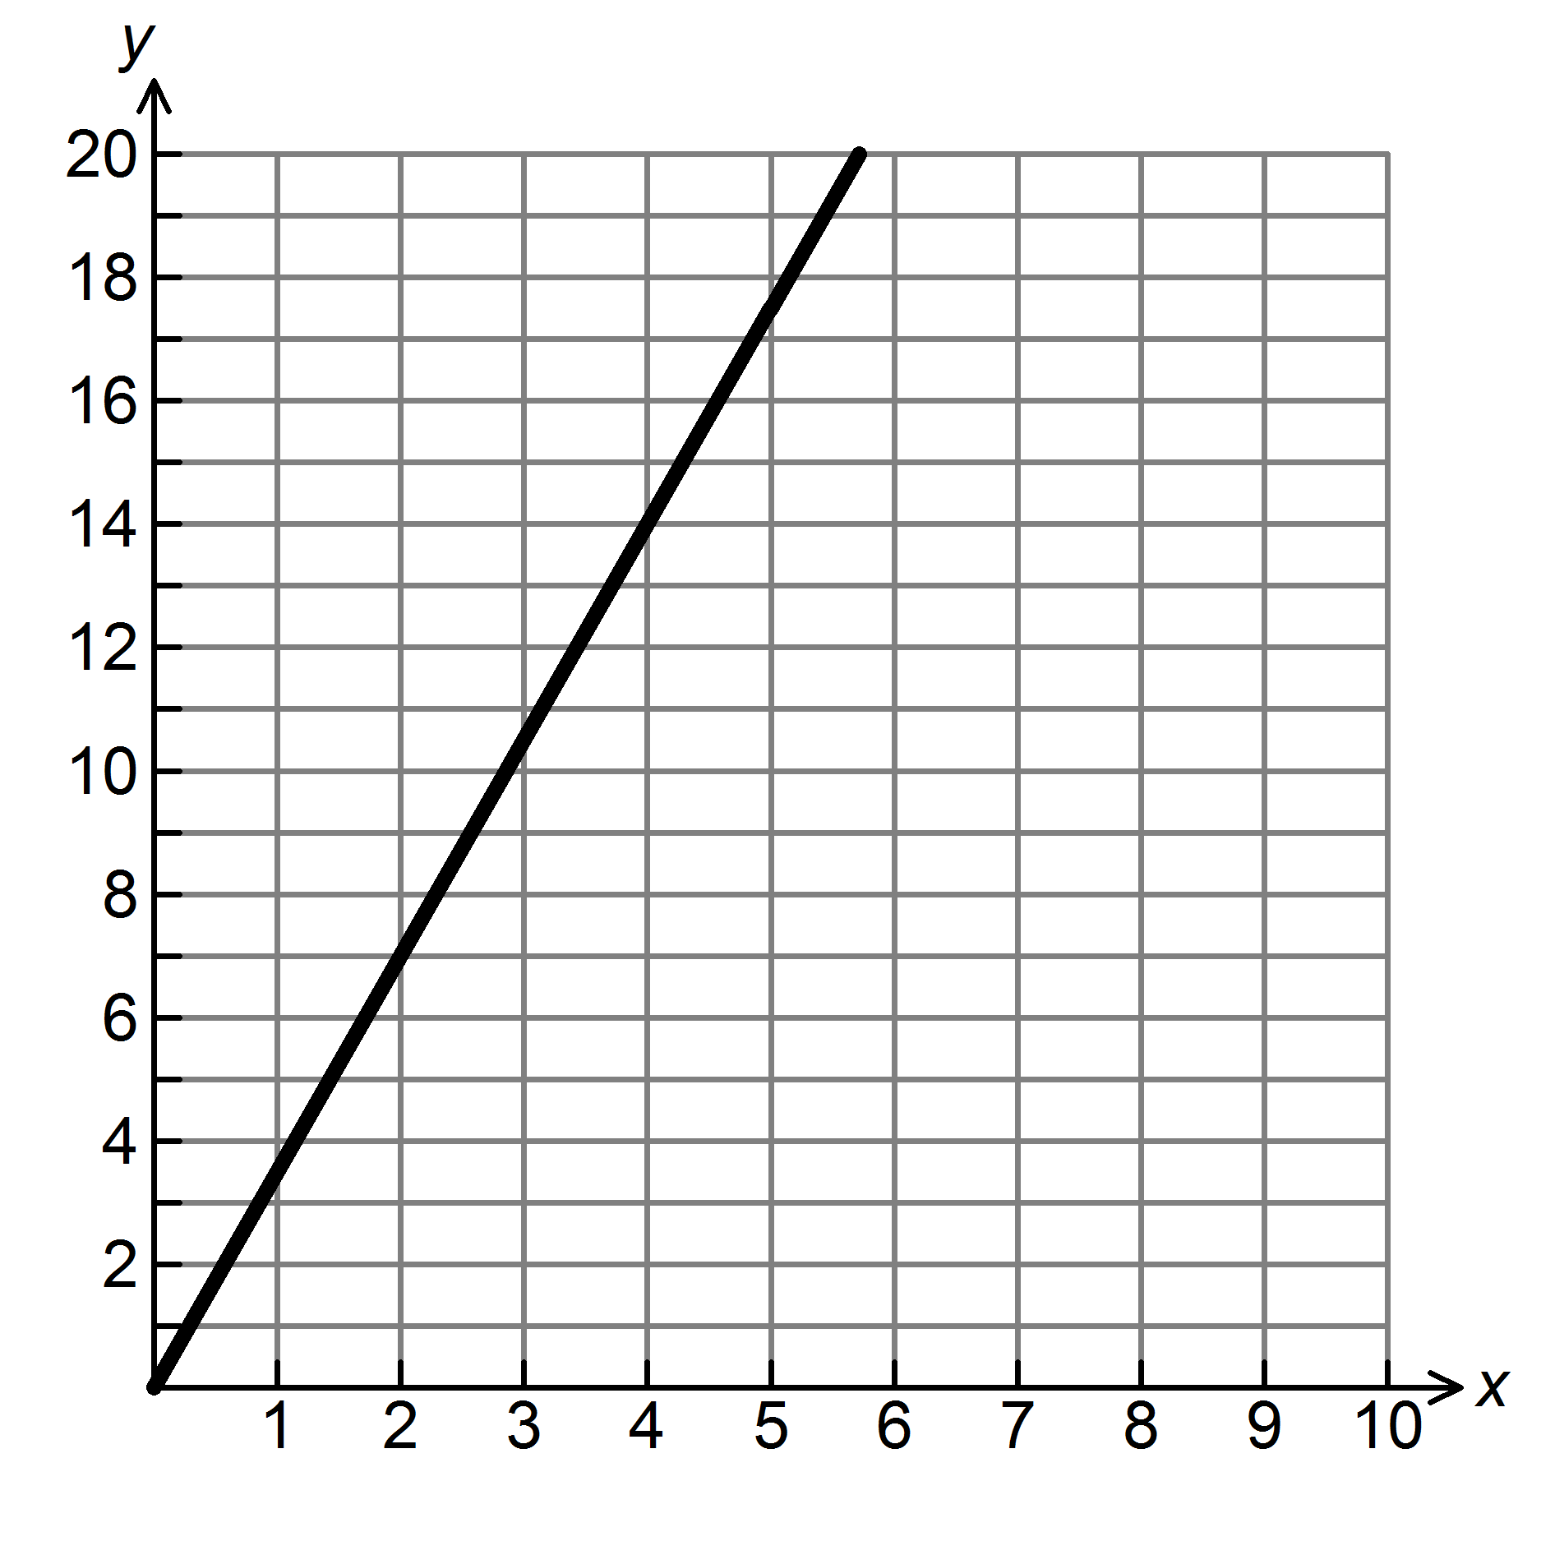

7. . ICEE’s at the movie theatre cost $4 apiece. Fill in the table and graph the ordered pairs.

|  |  |  |  |  |  |
| --- | --- | --- | --- | --- | --- |
| x (# of ICEE’s) | 0 | 1 |  |  | 4 |
| y (total cost) |  |  | 8 | 12 |  |

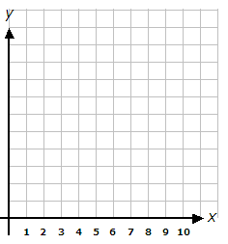

1. Maria’s Maids charges $150 per home. Fill in the table of values and write the direct variation equation.

 Direct varation equation: _________________________

|  |  |  |  |  |  |
| --- | --- | --- | --- | --- | --- |
| x (# of homes) | 0 | 2 |  |  | 10 |
| y (total money) |  |  | 600 | 750 |  |

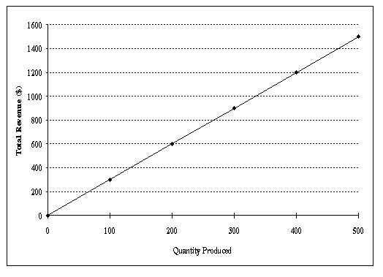9. What equation is shown by the graph below?

a. 

b. 

c. 

d. 