Unit 5: Fresh Water Remediation
S6E3. Students will recognize the significant role of water in earth processes
Part 1 (Surface Water):
- What percentage of the Earth is covered by water? Make a pie graph showing this

Part 2 (Salt vs. Fresh):
- What percentage of the water on Earth is salt water? Make a pie graph showing this

Part 3 (Frozen vs. Fresh):
- Where is most of the fresh water on Earth? Make a pie graph showing this

Part 4 (Energy)
5. How is the water cycle powered? (What gives it energy)? Draw a picture of this energy source

Part 5 (Water Cycle)
6. What is evaporation?

7. What is condensation?

8. What is precipitation?

9. What is transpiration?

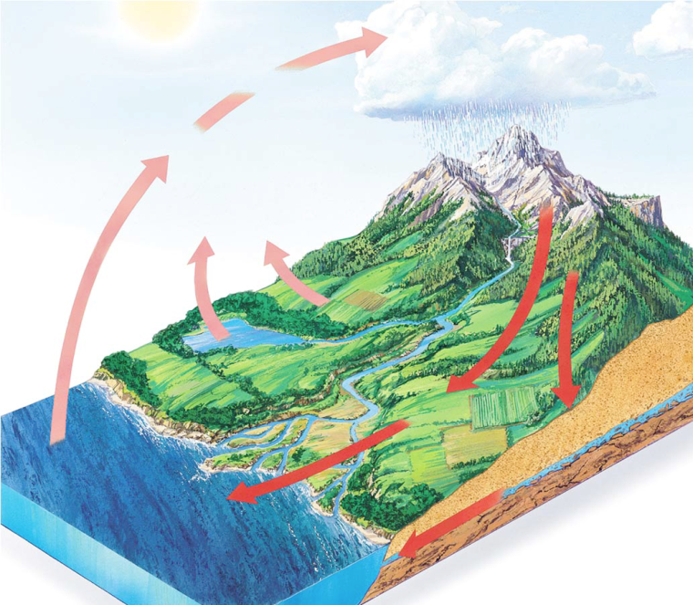
10-16. Label the following diagram with the following terms below.
Condensation Evaporation Runoff Precipitation Infiltration Transpiration Groundwater

Part 6 (Precipitation)

18. What is the difference between freezing rain and sleet?

19. What type of cloud is more likely to have precipitation?

20. Name four types of precipitation: __________________, ________________, _______________, _____________

21. Draw a picture of each type of cloud:

Part 7 (Runoff)
21. What is runoff?

22. Circle where runoff occurs on the diagram
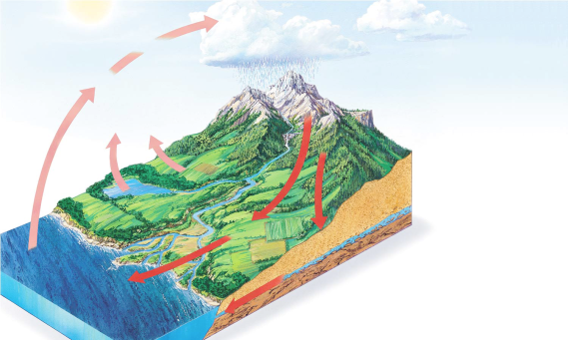
23. What type of disaster would be associated with runoff?

Part 8 (Conserve)
24. Why is it important to conserve water?

25. What are three ways you can conserve water?

