Unit 5 Remediation

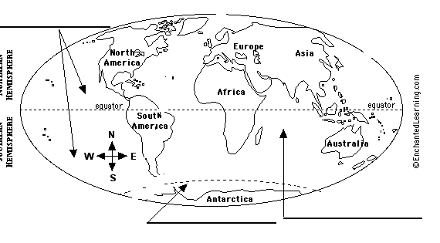
- Label the five oceans.

>>>Which ocean is the largest (and deepest)?
>>>Which ocean is the smallest (and shallowest)?

- Identify the features of the ocean floor.
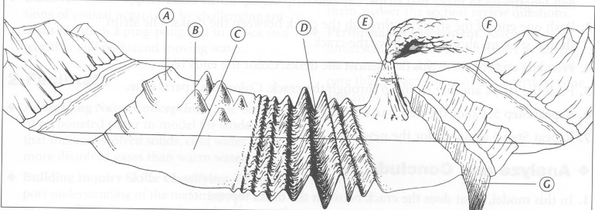

A: ______________
B: ______________
C: ______________
D: ______________
E: ______________
F: ______________
G: ______________

>>>Where does CONVERGENCE happen (creates subduction) on the diagram?

>>>Where does DIVERGENCE happen (creates sea-floor spreading) on the diagram?

- As you go deeper into the ocean
(choices: increase, decreases, stays the same):

>>temperature __________
>>water pressure _________

- _____________is a measure of how salty the water is (average is 3.5% in the oceans). What is the name of the main salt in the oceans? ______________

- List 3 natural resources we use from the oceans. Which are renewable? Which are nonrenewable?

- What causes ocean surface currents? What are the 2 types?

What causes ocean deep/density currents?

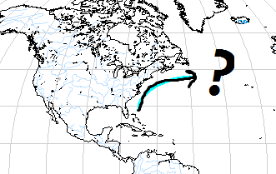
- Label the Gulf Stream Current and the California Current on the map, then write which one is a warm current and which is a cold current.

>>How do surface current affect climate?

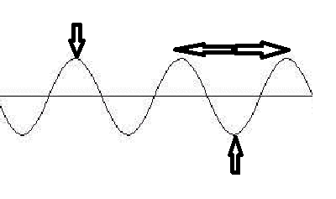
- What causes waves?

Label the parts of the wave:
(crest, trough, wavelength, wave height)

9. What causes tides?

How many high tides do we have each day? _____
How many low tides do we have each day? _____

Make a double bubble map of spring and neap tides below

